PPIT All Chapters Notes

Chapter 1 (i think, not sure)

Legal vs Illegal & Moral vs Immoral

Legal
Legal: Actions allowed or required by law.

Illegal
Illegal: Actions prohibited by law and punishable by the state.

Moral
Moral: Actions considered right according to ethics, values, or society.

Immoral
Immoral: Actions considered wrong or unethical, even if not illegal.

Rights
Rights define what individuals are entitled to, either morally or legally.

Types of Rights:
- Negative Rights: Require others to refrain from certain actions
  - Example: My right not to be killed, robbed, or harmed. Others must restrain themselves. (But it doesn’t mean others must actively protect me.)
- Positive Rights: Imply others have duties towards the right holder
  - Example: If I have the right to live, others must not only avoid killing me but also ensure my survival (food, shelter, safety).
- Legal Rights: Rights created, applied, and enforced by law
  - Example: Property rights, contractual rights. Violation leads to penalties.
- Moral Rights: Rights based on customs, traditions, ethics, and values. Independent of law
  - Example: Respect for elders, honesty in dealings. Violation brings guilt, not legal punishment

Moral vs Legal Status of Rights

Moral Status
- Decisions are based on:
  - Good or bad conscience
  - Religious teachings
  - Manners and ethics
- No formal punishment by law.
- Violation results in:
  - Guilt
  - Social disapproval
  - Loss of respect
Example
- Lying to someone may not be illegal, but it feels morally wrong.

Legal Status
- Actions are enforced based on:
  - Written laws
  - Regulations
- Violation leads to:
  - Fines
  - Punishment
  - Suspension or imprisonment
Example
- Breaking a law leads to legal consequences, regardless of personal beliefs.

Case Studies

Case 1: Polluting the Environment
- Moral: Don’t throw waste papers – it pollutes.
- Legal (Making the case legal how): Laws against littering, fines imposed.

Case 2: Giving Seat to Elderly in Bus
- Moral: Young people should offer seats (good manners).
- Legal: Reserved seats for elderly; fines for non-compliance.

Case 3: Password Privacy in an Organization
- Moral: Don’t share passwords – data can be stolen.
- Legal: Penalty/fine or suspension if passwords are leaked.

Case 4: Degree Issuance
- Moral: Institutions should only issue degrees if requirements are met.
- Legal: Degrees must be recognized by higher authorities (e.g., HEC). Invalid degrees are illegal.

Chapter 2: THE COMPUTING PROFESSION
Occupation
- Any activity/job a person does to earn a living.
- Requires: No specialized training, just skills or labor.
- Example: A carpenter, a driver, or even a doctor teaching in a college (teaching is their occupation, not necessarily their profession).

Profession
- A specialized career that requires extensive training, higher education, and expert knowledge.
- Requires: Formal education, certification, and adherence to ethical codes.
- Example: Doctor, Engineer, Lawyer, Chartered Accountant.

Differences Between Profession and Occupation
- Training & Knowledge
  - Profession: Needs advanced education & training.
    - Example: A surgeon studies medicine for years.
  - Occupation: May not require higher education.
- Basis of Payment
  - Profession: Paid for deep knowledge and specialized skills.
  - Occupation: not paid for their knowledge, but only for what they produce.
- Education Requirement
  - Profession: Requires higher education (degrees, licenses).
  - Occupation: No formal education required.
- Autonomy
  - Profession: Professionals often work independently, using their judgment.
  - Occupation: Workers are usually supervised by others.
- Responsibility
  - Profession: responsibility lies with the individual.
    - Example: A doctor is accountable for a patient’s treatment.
  - Occupation: Responsibility lies with the employer/manager.
- Ethics & Regulation
  - Profession: Guided by ethical codes and regulated by laws/statutes.

Example / Case
- A software engineer decides system design independently (profession).
- A factory worker follows instructions from a supervisor (occupation).

Characteristics of a Profession
- Mastery of an Esoteric Body of Knowledge: Professionals must acquire specialized, advanced knowledge, usually through higher education.
  - Often divided into:
    - Researchers → expand the knowledge base.
    - Practitioners → apply it in real-world settings.

- Autonomy: have independence in judgment and decision-making, justified by their expertise.
  - Example: A surgeon decides the best procedure during an operation without outside interference.

- Formal Organization: Professions are backed by a formal body that:
  - Controls admission.
  - Sets standards of competence.
  - License members.
  - Can discipline or expel members.
  - BCS / IEEE / ACM regulate computing professionals.

- Code of Ethics: Professions follow a code of conduct binding on all members, regardless of employer.
  - Example: Doctors take the Hippocratic Oath.

- Social Function: Professions exist to serve society and the public good, going beyond personal gain
  - Examples: Medicine → promotes public health and Law → upholds justice.

Professional Bodies

What is a Professional Body?
A professional association (professional body, organization, or society) is usually a nonprofit group that:
- Promotes and supports a particular profession.
- Protects the interests of professionals and the public.
It is typically formed when people with a shared professional interest come together. Example: IEEE and BCS
Example / Case
- Engineers forming a council to regulate engineering practices.
- IT professionals forming an association to set standards.

Functions of Professional Bodies
- Code of Conduct & Discipline:
  - Establish ethical rules for members.
  - Discipline those who violate these rules.
    - Example: Doctors violating medical ethics can lose their license.
- Knowledge Sharing & Development:
  - Spread best practices and new developments.
  - Done through journals, conferences, seminars, and now websites.
    - Example: IEEE publishes research papers and hosts global conferences.
- Education & Membership Standards:
  - Define what qualifications and experience are needed to join.
  - Often involve exams, certifications, or degrees.
    - Example: BCS requires specific IT qualifications for membership.
- Advisory Role to Government & Regulators
  - provide expert advice on policies, standards, and regulations.

Reservation of Title and Reservation of Function

Reservation of Title
Reservation of Title – the use of a professional title is legally restricted to qualified individuals.

Example / Case
- Only licensed individuals can call themselves “engineers” in some countries.

Reservation of Function
Reservation of Function – certain professional activities are legally restricted to qualified people.

Example / Case
- Only certified engineers can approve construction designs.

Is Computing a Profession?

Computing and Characteristics of a Profession
- Esoteric Knowledge:
  - Yes, computer professionals master specialized knowledge (e.g., algorithms, programming, databases, cybersecurity).

- Autonomy:
  - Varies, some (like researchers, consultants) have high autonomy, others (like in corporate IT roles) are closely supervised.

- Formal Organization:
  - Partially, no single global body regulates computing (like medicine or law). Instead, multiple professional bodies exist: IEEE, ACM, BCS, etc.

- Code of Ethics:
  - Yes, professional bodies (IEEE, ACM, BCS) have codes of conduct for members, but not everyone in computing is required to follow them.

- Social Function:
  - Yes, computing supports major social institutions (healthcare, education, government, business, security).

Conclusion: Computing is not fully a profession like medicine or law, where:
- A single licensing body controls entry/Unified governance
- Practice without a license is illegal/Strict licensing
- Universally enforced ethical codes.
But still computing has more professional; traits than most occupations, hence Computing is semi-profession or emerging profession.

Software Engineering

Software Engineering as a Profession

Software engineering appears to be one area of computing that is emerging as a distinct profession within the field of computing.

Motivation: trend seems to have been created by the initiative of individuals in the field concerned about the quality and safety of the software being produced and sold.

Developing software engineering as a distinct field involves several of the activities like:
- means identifying a unique body of knowledge that a person must possess to be a competent software engineer.
- Educational Requirements (Curriculum) development:
  - Standardized training and degree programs.
  - Goal: ensure trained professionals produce reliable, safe, and high-quality software.
- Licensing of Members:
  - Creating mechanisms for professional licensing.
    - Creating licensing organizations,identifying requirements for obtaining a license, such as passing an exam or acquiring a certain number of years of experience.
    - Example: Texas (USA) established licensing for Software Engineers.
- Code of Ethics

Software Development as Engineering

Engineering Perspective

The following are the constraints of Engineering:
- Meeting Requirements: Designs must function properly according to predetermined requirements (functionality, performance, reliability).
- Constraints of Time and Budget: Projects must be completed within deadlines and financial limits.

The Status of Engineers
legal status of engineers varies by country, but common rules include:

- Protected Title: Illegal to call yourself an “Engineer” unless registered with the State Engineers Registration Board.
  - Example: In Canada, only licensed professionals can use the title “Professional Engineer (P.Eng).”
- Company Names: A company cannot use “engineering” in its name unless it employs at least one registered engineer.
- Academic Programs: Programs with “engineering” in their title must be taught primarily by registered engineers.
- Engineering Work: It is illegal to perform engineering work unless supervised by a registered engineer.
  - Example: A junior software engineer can’t sign off critical safety software without a licensed senior engineer’s approval.

Washington Accord & Related Agreements

Washington Accord

An international agreement for mutual recognition of engineering qualifications, between signatory countries

Contains three agreements:
- Washington Accord (1989): Recognizes professional engineering degrees (normally 4 years).
  - Focus: Full engineering qualification.
- Sydney Accord (2001): Recognizes engineering technology qualifications (normally 3 years).
  - Focus: Technologists, B. Tech
- Dublin Accord (2002): Recognizes technician engineering qualifications (normally 2 years).
  - Focus: Technicians, Diploma

Example: A 4-year accredited engineering degree in Pakistan is recognized in other Washington Accord signatory countries (like USA, UK, Australia).

Summary of Accords
- Washington → Professional Engineer → ~4 years
- Sydney → Engineering Technologist → ~3 years
- Dublin → Engineering Technician → ~2 years

Professional Bodies in Computing

Professional Bodies – organizations that set standards, accreditations, and codes of conduct in computing.
- IEEE (1946): Institute of Electrical and Electronic Engineers (USA-based, global reach).
  - Has a Computer Society (IEEE-CS) with 100,000+ members.
- ACM (1947): Association for Computing Machinery (USA-based, global membership), 75,000+ members.
- BCS (1957): British Computer Society (UK), Became qualification awarding in 1960s.
  - In 2009 → renamed BCS: The Chartered Institute of IT.
- IEE (1871): Institution of Electrical Engineers.
- Other National Bodies:
  - 1961 → Italian Association for Informatics
  - 1965 → Computer Society of India
  - 1966 → Australian Computer Society
  - 1967 → Singapore & Irish Computer Societies
  - 1969 → German Informatics Society
  - 1976 → Computer Society of Sri Lanka

Code of Conduct in Computing

What is a Code of Conduct?
- A set of ethical rules members must follow.
- Ensures responsible and professional behavior.
All major bodies (like BCS, ACM, IEEE) have their own codes.

BCS Code of Conduct – Main Sections
- The Public Interest: Protect public health, safety, privacy, and security.
  - Respect rights of third parties.
  - Avoid personal bias in professional work.
    - Ensure fairness in professional judgments
    - Remain neutral and evidence-based in work
    - Example: A project manager evaluates vendor proposals based on cost and quality, not on personal friendships with one of the vendors.
  - Promote equal access to IT benefits: e.g. making an accessible websites, and affordable tools

- Duty to the Relevant Authority:
  - Avoid conflicts of interest.
  - Avoid misrepresentation: Don’t provide false or misleading information.
    - Example: A developer must not claim a system is “fully secure” if known vulnerabilities exist
  - Do not disclose confidential information without consent.

- Duty to the Profession:
  - Uphold the reputation of the profession.
    - Example: An IT consultant avoids exaggerating system capabilities to win a contract, because dishonesty damages the profession’s reputation.
  - Improve standards by contributing to their development and enforcement.
    - Example: A software engineer participates in IEEE/ACM working groups to develop new cybersecurity standards.
  - Support fellow professionals in growth and development.
    - Example: A senior developer mentors junior team members

- Professional Competence and Integrity:
  - Only accept work within your competence.
  - Do not misrepresent your expertise.
  - Keep knowledge up to date.
  - Respect alternative viewpoints and give/accept honest criticism.
  - Avoid harm through negligence or false claims.
  - Reject bribery.

Chapter 3: WHAT IS AN ORGANIZATION

LEGAL FORMS OF ORGANIZATIONS

What is an Organization?
- A group of people working together in a formal and organized way.
- Must have legal existence.
- Can be private or government-based.
Examples:
- Schools, colleges, hospitals, banks.
- Private companies, government departments.
- Even your own startup/business.
Is a jail an organization?
- Yes. It has staff, structure, rules, and legal status.
Example/Case:
- A hospital has doctors, nurses, admin staff, and follows laws → it is an organization.

Types of Organizations

1. Commercial Organizations
- Aim: make profit.
- People combine skills, resources, and strategies.
- Legal forms include:
  - Sole trader
  - Partnership
  - Cooperative
  - Limited company
Example:
- A software house selling IT services to clients.

2. Non-Commercial Bodies
- Aim: not for profit.
- Often run by charities or government.
- Staff may work as volunteers or for low pay.
Examples:
- NGOs, welfare trusts, public hospitals.
Example/Case:
- A charity providing free IT training to poor students.

Sole Trader / Proprietor

Definition
- A single person runs the business.
- No legal formalities needed to start.
- Optional registration for tax/customs if income is high.
- About 73% businesses in the US follow this model.

Key Features
- Owner = business.
- Easy to start and manage.
- Full control.

Risk
- Unlimited liability → personal assets at risk.
- Business debts = owner’s personal debts.
Example/Case:
- A freelance web developer running business alone.
- If business fails, personal savings/home may be used to pay debts.

Partnership

Definition
- Two or more people run a business to make profit.
- Not a limited company → treated as partnership by law.
- About 7% businesses in the US.

Key Points
- Governed by Article (Agreement) of Partnership.
- Profits shared as agreed.
- Difficult to liquidate.
- Ownership not transferable.
- Partnership may dissolve if a partner dies.
- Problems: share ratio disputes, conflicts.
Example/Case:
- Three friends open a mobile app company and share profits 40–30–30.
- If one leaves/dies, partnership may end.

Cooperatives

Definition
- Organization formed for mutual benefit of members.
- Important in agriculture and similar sectors.
- Have special legal status.

Key Points
- Members are also users/owners.
- Democratic control (one member, one vote).
- Legal existence.
Example/Case:
- Farmers form a cooperative to sell crops together and get better prices.
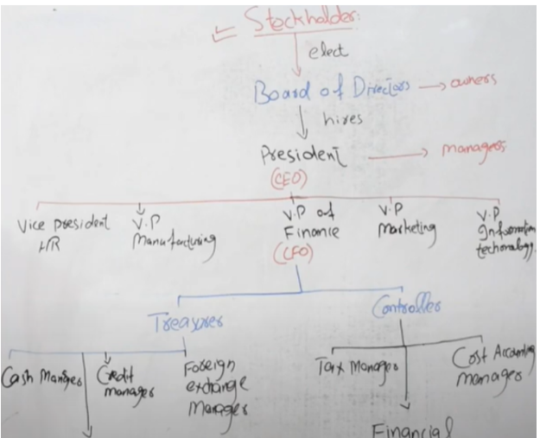

Limited Companies (Corporate Organizations)

Definition
- A business with separate legal identity from its owners.

Three Fundamental Principles
- Corporate Legal Identity
  - Company is a separate legal person.
  - Can own property, sue, and be sued.
- Ownership by Shares
  - Capital divided into shares.
  - Owners are shareholders/members.
  - Shares can be bought and sold.
- Limited Liability
  - Shareholders are not personally liable for debts.
  - Maximum loss = money paid for shares.
Other Features
- Generates about 90% of revenue in economies.
- Has common & preferred stockholders.
- Subject to double taxation.
- No secrecy → public accounts.
Example/Case:
- You buy shares in a tech company worth Rs. 50,000.
- If company goes bankrupt, you lose only Rs. 50,000, not your house.

Constitution of a Limited Company
To register, a company must have a constitution:
- Memorandum of Association
- Articles of Association

Memorandum of Association
Contents:
- Company name (unique, no misleading words).
- Registered office country.
- Objects clause → type of business.
- Liability clause → liability is limited.
- Authorized share capital and value of shares.
- Declaration of association → founders agree to form company and take shares.
Purpose:
- Defines company’s identity and scope.
Example/Case:
- A software company states its object: “to carry on IT and software services business.”

Declaration of Association
- Statement by founders that they want to form the company and take shares.
Example:
- 5 founders agree to take 1,000 shares each.

Articles of Association
- Rules for internal management of company.
- Covers:
  - Share transfer
  - Director powers
  - Meetings, voting, etc.

Table A
- A model set of articles given in law.
- Companies usually adopt it and modify if needed.
Example:
- A startup uses Table A instead of writing its own rules from scratch.

Directors

Who are Directors?
- People who run and manage the company.

Duties
- Duty to shareholders and employees.
- Act in company’s best interest.
- Avoid personal gain.
- Liable for wrong or negligent decisions.
Example/Case:
- A director avoids awarding a contract to his own firm to prevent conflict of interest.

Setting Up a Limited Company

Steps
- Group of people agree to:
  - Invest money.
  - Pursue a stated goal.
- Register under company law.
- Prepare memorandum & articles.
- Optional: hire accountant/legal advisor.
- Option: buy an off-the-shelf (template) company and customize it.
Example/Case:
- Four IT graduates register a software house as a private limited company and start operations.

Chapter 4: STRUCTURE AND MANAGEMENT OF ORGANIZATION

Introduction

Definition
- An organization is a group of people working together in a formal way.
- Work is divided, and there are rules about who does what.

Key Idea
- The way tasks and people are grouped is called the organizational structure.
- Structures differ, but many organizations share common patterns.
Example/Case:
- In a software house, developers code, testers test, managers plan → each has defined roles.

Types of Organizational Models
- Bureaucratic model
- Organic model
- Matrix management

The Bureaucratic Model
found in most large and many smaller organizations.

Characteristics:
- Tasks are divided into smaller, well-defined jobs. Each person becomes an expert in their area; management can thereby hold the jobholders responsible for the effective performance of their duties.
- Work is standardized by rules so that tasks are done the same way by everyone and therefore no problems with the coordination of different tasks.
  - Strict procedure and process to be followed for each job
- Everyone (and hence each unit) in the organization is accountable to one and only one manager.
- To ensure personal relationships do not interfere with the organization’s performance, employees must communicate with both the clients and employees in an impersonal and formal manner
- Recruitment is based on qualifications and employees are protected against arbitrary dismissal (Termination without valid reasoning). Promotion is based on seniority and achievement. The model assumes that once an employee is recruited, they will stay in the organization for their entire career.

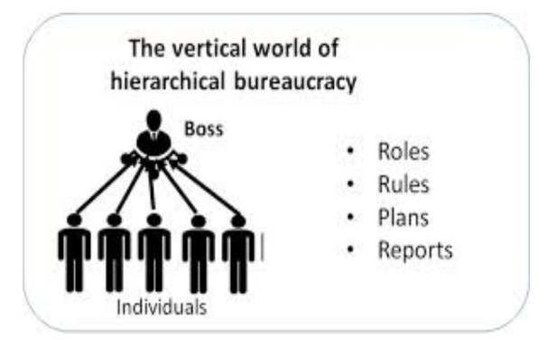

Key Elements:
- Roles: Clearly defined jobs for each individual.
- Rules: Standardized procedures everyone must follow.
- Plans: Strategies and tasks are made at the top and passed down.
- Reports: Employees report progress and results back up to the boss.

The Organic Model
Unlike bureaucracy (rigid, rule-based), the organic model is flexible, people-centered, and adaptive.

Characteristics/Key-features:
- Common in Small Professional Companies: Works best in dynamic, creative environments.
  - Example: A software house where programmers, designers, and testers work collaboratively, not under rigid hierarchy.
- Used in Academic Institutions
- Flexibility, Not Always Enough for Effectiveness: Just having a flexible, supportive culture isn’t always enough; processes still matter.
  - Example: A startup may be highly innovative, but without some structure, it may fail to scale properly.
- Competing Claims with Bureaucracy: Both models claim they can be universally applied
- Neither model fits all; the right choice depends on the situation.

Bureaucratic: Rigid, rule-based, hierarchy, stability, specialization.
Organic: Flexible, collaborative, people-oriented, adaptive, innovation-driven.

Matrix Management
Core Idea:
- Unlike bureaucracy (one boss per person), matrix management allows individuals to report to more than one manager.
- It is mainly used in project-based, high-technology(fast-changing) companies where resources and expertise need to be shared across multiple projects.
- Requires clear rules to prevent conflicts between managers.

Example:
- Imagine a network specialist in a systems integration company, They might work on multiple projects and at the same time, they report to their functional manager. So, the specialist has two types of managers:
- Project Manager(s): Responsible for deadlines and deliverables in each project.
- Functional Manager: Responsible for long-term skills, training, and career growth.

Why popular: Modern projects (especially in IT, R&D, and engineering) need specialists working across multiple projects, bureaucracy is not able to handle this, hence MM is designed to provide this flexibility.

Problems / Challenges:
- Employees may feel confused or overloaded if managers give conflicting instructions.
- Requires strong communication and conflict-resolution rules.
- In practice, results have been mixed — some companies succeed with it, others find it causes power struggles.

Where It Works Best: Large consulting firms, IT companies, aerospace, and R&D organizations (where expertise is scarce and must be shared).

STRUCTURING PRINCIPLES
Organizations may be structured by:
- Function
- Geography
- Product line
- Market sector
- Technology
- Operations (projects/production)

Structure by Function

Idea
- Group people by type of work:
  - Operations
  - Administration
  - Sales & Marketing
  - Research & Development

Typical Functions
- Engineering
- Manufacturing
- Marketing
- Finance & Accounting
- Personnel
- R&D

Advantages
- Centralized control.
- Strong functional expertise.
- Efficient for routine tasks.

Disadvantages
- Poor coordination between functions.
- Rivalry between departments.
- Narrow viewpoints.
Example/Case:
- A company has separate IT, HR, Finance, and Marketing departments.
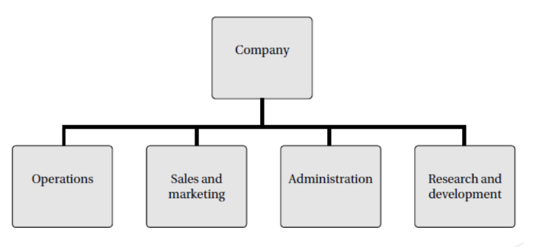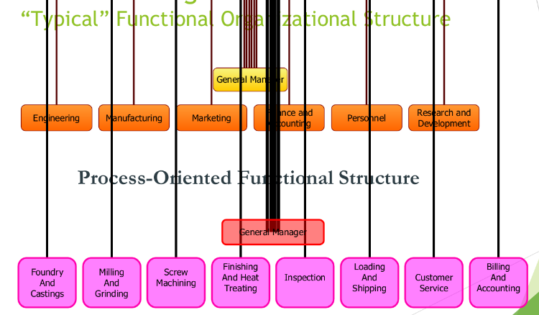

Structure by Geography

Idea
- Group activities by region/location.
- Common in multinational companies.

Why Used
- Different laws in countries.
- Local customer needs.

Advantages
- Tailored strategies for regions.
- Better local coordination.
- Uses local resources.

Disadvantages
- Hard to keep same company image.
- Duplication of staff/services.
- Higher cost.
Example/Case:
- A company has offices for Asia, Europe, and America with local managers.
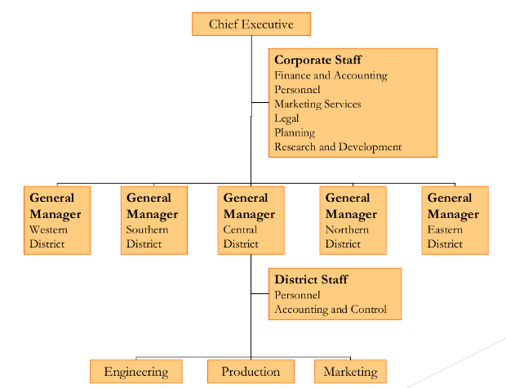

Structure by Product Line

Idea
- Structure based on types of products/services.

Examples
- Car company → cars, trucks, bikes divisions.
- Software firm → development, consultancy, training.

Strength
- Focus on each product/service.
- Clear responsibility.

Weakness
- Duplication of resources.
Example/Case:
- A software company has separate teams for ERP software, mobile apps, and cloud services.

Structure by Market Sector

Idea
- Divisions based on customer type/industry.
- e.g., education, healthcare, banking.

Advantages
- Understand customer needs.
- Better communication with clients.
- Sales staff speak customer’s “language”.

Disadvantages
- Poor sharing of expertise between divisions.
- Risk of focusing only on old markets and missing new opportunities.
Example/Case:
- An IT firm has separate teams for banks, hospitals, and schools.

Structure by Technology

Idea
- Divisions based on technical expertise:
  - AI
  - Databases
  - Web systems
  - Communications
  - Real-time systems

Problems
- Customers need multiple technologies.
- Hard to match tech to customer needs.
- Engineers often multi-skilled.
- Sales can’t predict needed technology.
- Not customer-focused → sell what they have, not what is needed.
Example/Case:
- A client wants a web system + database, but company divisions are separate and don’t coordinate.

Structure by Operations

Types
- Project-based: temporary teams, long duration.
- Production-based: permanent teams, repetitive tasks.

Key Points
- Projects used in:
  - R&D
  - System implementation
  - Office relocation
- Production:
  - Regular service or product delivery.
Example/Case:
- Project: develop a new banking app (6 months).
- Production: daily customer support team.

Depth of Structure

Definition
- Number of layers/levels in hierarchy.

Terms
- Flat → few levels, wide span of control.
- Tall/Deep → many levels, narrow span.

Span of Control
- Number of people reporting to one manager.
Example/Case:
- Flat: Startup with CEO and developers.
- Tall: Army with many ranks.

Centralization vs Decentralization

Centralized
- Power at the top.
- Little delegation.
Pros: Control, uniformity
Cons: Slow decisions

Decentralized
- Power delegated to lower levels.
Pros: Fast decisions, motivation
Cons: Less uniform control
Example/Case:
- Centralized: All approvals by head office.
- Decentralized: Branch managers decide locally.

Setting Up a Structure in Practice
- Real organizations use a mix of structures.
- Combination chosen to suit goals and environment.
Example/Case:
- A software house uses:
  - Functional (dev, test),
  - Project teams,
  - Market sectors (education, finance).

JOB DESIGN

Job Rotation
- Employees rotate through different jobs.
- Prevents boredom.
- Builds multiple skills.
Example:
- A trainee works in testing, support, then development.

Job Enlargement
- Increase range of tasks at same level.
- Adds variety, not authority.
Example:
- A support engineer also handles documentation.

Job Enrichment
- Add higher-level responsibilities.
- Motivates self-driven staff.
- Gives sense of importance.
Example:
- A developer also plans modules and mentors juniors.

Chapter 5: FINANCING A STARTUP COMPANY

Financing a Start-up Company

Introduction
- Many graduates aim for independent work by starting their own company instead of working for others.
- In computing, new graduates often plan to set up software or IT companies.
Example / Case
- Mobile app startups, software development firms, IT consultancy, or tech service companies.

Why Capital is Needed
- To buy materials/equipment for the product or service
- To cover living expenses while developing the product
- Customers usually do not pay upfront, so cash reserves are required
Examples
- Mobile phones, burger shop, house painting services, computer services, software packages

Factors Involving Capital
During product/service development (when revenue is zero), capital is needed for:
- Salaries – for founders and any staff
- Premises – rent, utilities, rates
- Equipment and consumables – computers, tools, software
- Advertising and marketing – promotion of products/services
- Miscellaneous expenses – stationery, travel, minor costs
- Interest – on any borrowed money
Example / Case
- Developing a software package requires paying developers, office rent, marketing costs, and equipment before earning revenue.

The Business Plan
Definition
- A document that explains your business idea and convinces funders/investors that it is realistic and feasible.
Purpose
- Plan and focus business ideas
- Define targets, benefits, and profit goals
- Approach investors, banks, or funders confidently

Contents of a Business Plan
- Company Description
  - What the company does
  - Technical feasibility
  - Founders’ expertise
- Market Analysis
  - Target market
  - Market size estimation
  - Competitor assessment
- Financial Predictions
  - Budgets
  - Cash flow forecasts
  - Projected balance sheets and profit & loss accounts
Example / Case
- A software startup plans to develop a productivity app, shows market demand, calculates expenses, and predicts revenue growth to secure funding.

Important Notes
- Not a prediction
  - A business plan is a scenario, showing the company has a reasonable chance of success
  - Helps identify potential weaknesses before starting the business
- Moral Story
  - Like the village girl making castles in the air – without a realistic plan, ideas may fail
Example / Case
- Attempting to create a complex software app without considering resources and market needs often leads to failure.

Sources of Finance for a Start-up Company

1. Grants
Definition
- A sum of money given to a company for a specific purpose
- Not repayable
- Only available from:
  - Government (local or national)
  - Unions
  - Occasionally charities
Purpose & Conditions
- Usually to assist with capital investment (premises, equipment)
- Often require raising additional capital from other sources
- Limited to a proportion of proven capital investment
Example / Case
- A software company receives a government grant to buy computers and servers for development.

2. Loans
Definition
- Money lent to a company, repayable with interest
- Fixed or variable interest rates
- Usually for a fixed period
- Company must repay eventually
Additional Points
- Lenders may recover the loan from company assets if it goes into liquidation
- Usually security is required
Example / Case
- A startup takes a bank loan to rent office space and purchase development tools

3. Equity Capital
Definition
- Money invested in exchange for a share of company ownership
- Investors become co-owners and share profits
Business Angels / Venture Capitalists
- Business angels: wealthy individuals investing in start-ups or small firms aiming for rapid growth
- Venture capitalists: firms that provide large-scale investment for expansion
Example / Case
- A tech entrepreneur gives 20% equity to an angel investor to fund app development.

4. Gearing (Leverage)
Definition
- The relationship between loan capital and equity capital
- Measures how much of a company’s operations are funded by lenders vs shareholders
Importance
- High gearing = more debt, higher financial risk
- Low gearing = more reliance on equity, less financial risk
Example / Case
- A company with $100,000 equity and $50,000 loans has a gearing ratio of 1:2, showing moderate financial leverage.

Budgeting and Monitoring:

Budget – financial plan prepared for a specific period of time; commonly one year that estimates expected revenues and expenses.
- It helps an organization plan, control, and evaluate its financial activities to ensure resources are used efficiently.
- Can be prepared for:
- Individuals or families
- Businesses or organizations
- Governments and countries

Purpose and Scope:
- prediction of an organization’s future financial position
- A complete budget includes forecasts for all major financial statements—income statement, balance sheet, and cash flow statement—but the most critical focus is on the income and expenditure budget, which determines profitability and sustainability.

Budgeting Process: iterative (repetitive) and refining process.
- The first draft often shows expenses exceeding income.
- Managers then make adjustments, reducing unnecessary costs or increasing revenue
- This process continues until the budget reflects a realistic scenario where sales exceed expenditure, resulting in a reasonable profit margin.

Monitoring Performance:
- The figures in the budget are split into monthly or weekly figures.
- When the actual figures of a month become available, they are compared with the budgeted figures.
- Real expenditure of any field exceeds the budgeted value, reason is determined quickly and remedial action is taken.

Sales and Order Intake:
Sales: sale is a transaction between two parties in which the buyer receives goods, services, or assets in exchange for money or equivalent value.
- Generating revenue for an organization, necessary to cover costs and ensure profitability

Order Intake: receipt or processing of customer orders for products or services.
- It measures a company’s production and customer demand by tracking the total value or number of orders received within a specific period.

Importance of Sales and Order Monitoring: Company’s cost, pricing decisions and level of permissible overheads, all depend on the volume of sales achieved
- Hence monitoring is essential managerial responsibility, as it helps in evaluating financial health, identifying market trends, and making informed decisions about pricing, production, and investment.

Costing
Process of determining all expenses incurred in producing a product or providing a service, helps influence pricing and hence overall profitability.
Key Factors Affecting Selling Price:
- The cost of production or provision
- Market conditions (demand and competition)
- Price and availability of competing products
- Elasticity of demand (customer sensitivity to price changes)

Types of Costs:
- Cost of equipment: how much the company paid for the equipment.
- Cost of labour: sum of all wages paid to employees.
- Overheads: expenses that cannot be directly linked to a specific product or service but are necessary for operations.
  - Example: Marketing and advertising expenses, Managerial salaries, cost of proposal preparation
  - Types:
    - Departmental Overheads: Costs associated with a specific department and should be covered by that department’s revenue.
    - Corporate Overheads: Costs related to the entire organization, such as head office administration and corporate governance.

Pricing
determining the value a producer will get in the exchange of goods and services, the price charged by a company is constrained by the fact that revenue > cost of product
Software companies typically face three main pricing contexts:
- Service-Based Pricing (Effort-Based): Pricing a bid for services such as consultancy, payment is based on the effort or time supplied.
- Contract-Based (Fixed Price) Projects: Pricing a bid for a contract to deliver bespoke software (opposed to off-the-shelf (OTS) software) at a fixed price.
- Product-Based Pricing: Setting a price for a software product that the company has developed independently and intends to sell to multiple customers.

Capital and Its Maintenance
- Capital is generally regarded as a guarantee of the company’s ability to meet its financial obligations. It provides confidence to:
- Investors, that their contributions are safeguarded; and
- Lenders, who assess the company’s capital strength before granting loans.
- To maintain capital:
- A company is not allowed to issue shares at a discounted value.
- A company cannot pay back to the shareholders any of their original contributions.’

Auditing
examining an organization's financial records to determine if they are accurate and in accordance with any applicable rules , regulations, and laws.
- Auditor Reports along with company accounts
- Purpose:
- Provide members of the company and public with assurance that accounts are fair
- It is not practicable for auditors to check every financial transaction.
- They work by:
- Examining the adequacy of the company’s financial procedures
- Making detailed checks on a small sample of transactions and assets.

Annual Statements
All limited companies are required to produce annual accounts(balance sheet, profit and loss account, cash flow statements ) and to give a copy of them to the registrar of companies for filing.
- Filing is done to SECP (Securities and Exchange Commission of Pakistan)

On which financial statements does a company report its long-term debt?
→ Long-term debt appears on the Balance Sheet, under the Liabilities section as Non-Current Liabilities.

Which financial statement can I find non-current assets on?
→ non-current assets on the Balance Sheet (Statement of Financial Position).

Owner’s Equity: owner’s claim on the company after all debts are paid. It’s what’s left over if the company sells all assets and pays all liabilities.
- Capital / Share Capital – money invested by owners or shareholders
- Retained Earnings – profits kept in the business instead of distributed
- Drawings / Dividends – money withdrawn or distributed to owners (subtracted)

Dividends:
- Not Declared = + retained Earnings
- When declared / not paid: - retained earning , + dividend Payable
- When paid: -dividend Payable, -Cash

Drawings: Drawings reduce owner’s equity(owners capital) and reduce total assets (cash)

Chapter 6: FINANCIAL ACCOUNTING

The Balance Sheet
Definition
- Shows what the company owns (assets) and owes (liabilities) at a given point in time

Key Terms
- Current Assets – assets likely to be converted into cash within a year
  - Example: cash, accounts receivable, inventory
- Fixed Assets – long-term assets used in business
  - Example: land, buildings, machinery
- Depreciation – reduction in value of fixed assets over time
  - Example: machinery losing value after 5 years
- Tangible Assets – physical assets
  - Example: computers, vehicles
- Intangible Assets – non-physical assets
  - Example: patents, software licenses
- Current Liabilities – debts payable within a year
  - Example: short-term loans, accounts payable
- Fixed Liabilities – long-term debts
  - Example: bank loans, bonds

Example / Case
- A startup owns office computers ($10,000), cash ($5,000), owes short-term suppliers ($3,000), and a long-term bank loan ($15,000).
  - Assets: $15,000
  - Liabilities: $18,000

The Balance Sheet Example
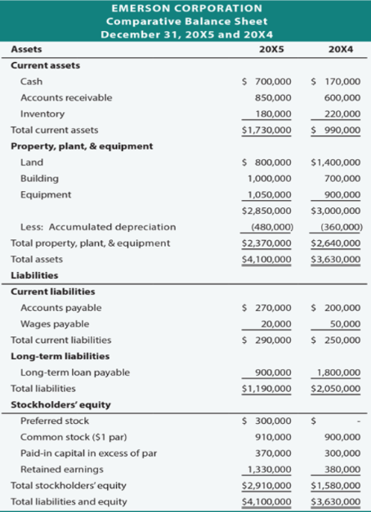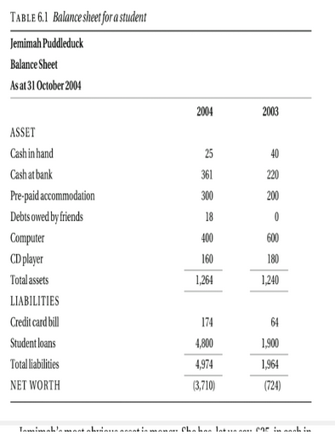

The Profit and Loss Account (P&L) – also known as Income Expenditure Account
Definition
- Shows how much money the company has received (income) and spent (expenses) over a specific period, usually a financial year.
- For non-profit organizations, it is called the Income and Expenditure Account.
Purpose
- Measures financial performance of the business
- Helps determine profit or loss for the period
Example / Case
- A software company earns $50,000 from services and spends $35,000 on salaries, rent, and utilities:
  - Profit: $15,000

Important Formulas!
Earning Before Interest and Income Tax (EBIT) = Revenue - Expenses
Profit Before Tax (PBT) = EBIT - Interest
Profit After Tax (PAT) = PBT * (1 - (Tax Rate / 100))
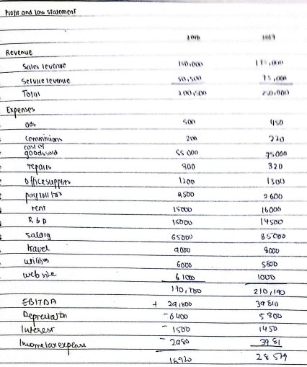

Cash Flow Statement
Definition
- Shows the movement of cash in and out of the company during a specific period
- Links the Balance Sheet and Profit & Loss Account to capital expenditure
Purpose
- Tracks sources and uses of cash
- Helps understand liquidity and how money is spent or received
Example / Case
- A company earns $50,000 revenue, pays $20,000 in salaries, $5,000 for equipment, and invests $10,000 in marketing:
  - Cash inflow: $50,000
  - Cash outflow: $35,000
  - Net cash flow: $15,000
Analogy
- Like parents asking children “where the money came from and where it went”, a cash flow statement shows the flow of money in the business.

Chapter 6: SOLVED NUMERICAL for Balance Sheet
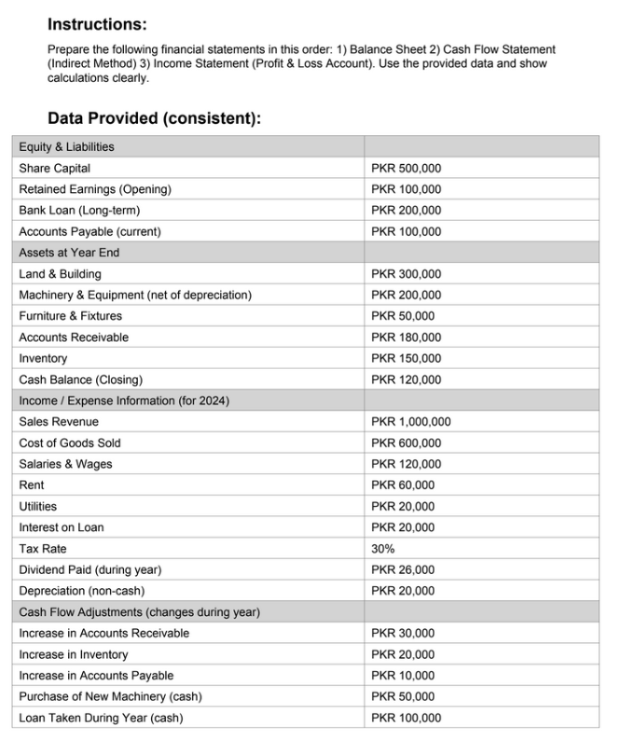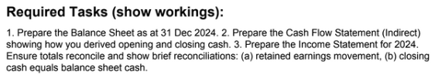

Answer:
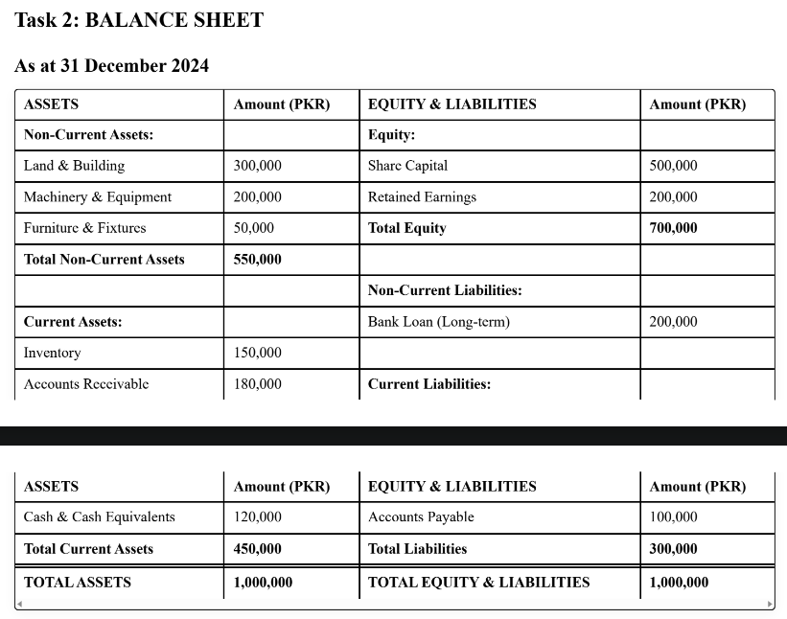

Chapter 6: MID 2 Solved Numerical For Cash Flow, Income Statement
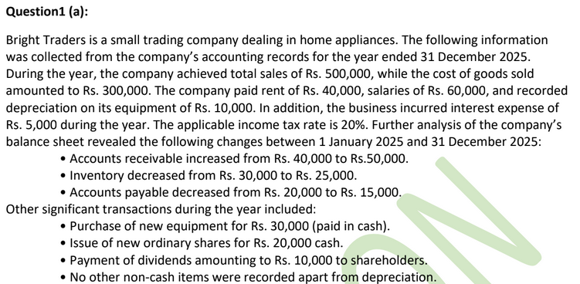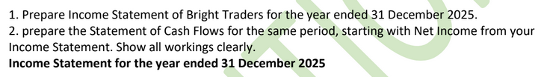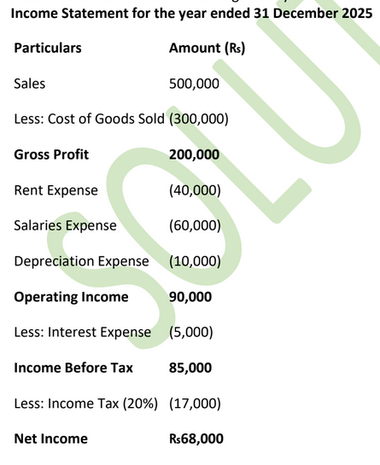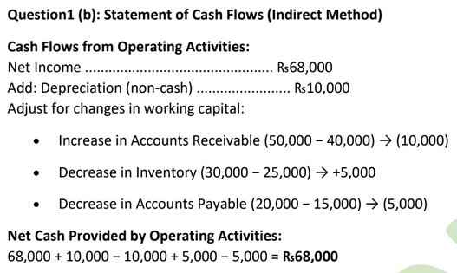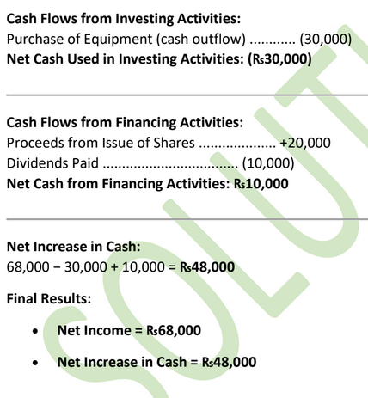

Chapter 7: MANAGEMENT ACCOUNTING

Cost of Labour
The cost of labour is the total expense incurred by an organization in employing a worker. It is not limited to the employee’s salary.
In most countries, employers are legally required to pay additional taxes or contributions for each employee. These may include:
- Employer’s National Insurance (UK)
- Social Security contributions
- Pension contributions or other statutory benefits
These contributions are usually calculated as a percentage of the employee’s salary.
In some countries, this percentage can be as high as 60% of the salary, while in others it may be significantly lower.

Formula:
Cost of Labour = Salary + Employer Contributions

Example:
If an employee earns 50,000 and the employer contribution is 20%:
Employer contribution = 10,000
Total cost of labour = 60,000
This total cost is used in costing, budgeting, and pricing decisions, not just the salary amount.

Overheads
Overheads are costs that cannot be directly linked to a specific product or service but are necessary for the overall operation of the business.

Examples of Overheads:
- Rent of office or factory
- Electricity and water
- Internet and telephone
- Administrative staff salaries
- Equipment depreciation
- Maintenance and security
Since overheads are indirect costs, they are usually shared or distributed across products or services using appropriate methods.
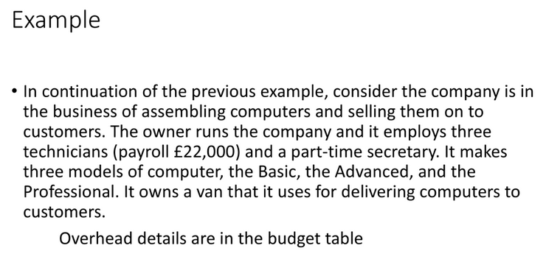
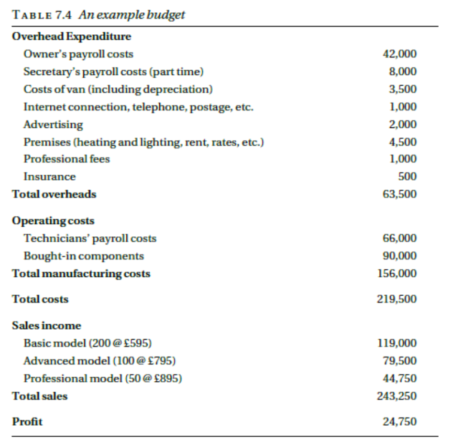
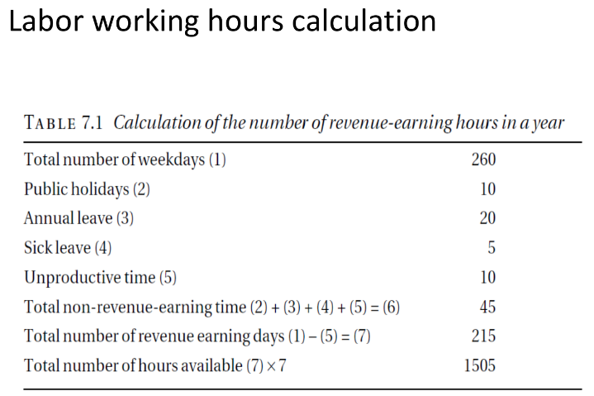

PAYROLL (DIRECT LABOUR COST)
Definition:
Payroll (also called direct cost) is the total cost of employing an employee, not just their salary.
What Payroll Includes:
- Employee’s basic salary
- Employer’s social security contributions
- Any other costs directly related to employing that person
Key Idea:
Payroll cost reflects what the employee actually costs the company, not what they receive.
Example:
A technician earns a salary of £20,000 per year.
After adding employer contributions and related costs:
- Payroll cost = £22,000 per year
This £22,000 is the true cost of employing the technician.

DIRECT COST PER HOUR
Concept:
To calculate the cost of one hour of labor, divide annual payroll cost by total working hours per year.
Formula:
Direct cost per hour = Payroll cost / Annual labor hours
Given:
- Payroll cost = £22,000
- Annual working hours = 1,505
Calculation:
£22,000 / 1,505 = £14.62 per hour
Interpretation:
Every hour the technician works costs the company £14.62.
Example:
If the technician works 10 hours on a task:
- Labor cost = 10 × £14.62 = £146.20

COST OF LABOUR IN PRODUCT CONSTRUCTION
Important Point:
Labor cost is not the only cost involved. Even a single technician has additional costs such as:
- Equipment
- Software
- Setup and configuration time
Scenario:
- Computer hardware cost = £200
- Assembly + installation time = 10 hours
- Hourly labor cost = £14.62
Calculation:
Total cost = £200 + (10 × £14.62)
Total cost = £346.20
Meaning:
The final product cost includes both material cost and labor cost.

EXAMPLE 1 – OVERHEAD COSTING
Given Data:
- Total overhead cost = £63,500
- Number of technicians = 3
- Payroll per technician = £22,000
- Labor hours per technician = 1,505
- Expected sales = 350 units
Hourly labor cost:
£22,000 / 1,505 = £14.62
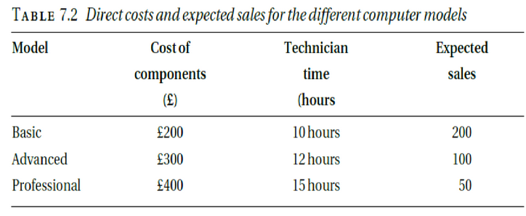

METHOD 1: FIXED OVERHEAD PER UNIT
Concept:
Overhead is spread equally across all units expected to be sold.
Calculation:
Overhead per unit = £63,500 / 350 = £181.43
Cost Calculations:
- Basic model:
£181.43 + £200 + (10 × £14.62) = £527.63
- Advanced model:
£181.43 + £300 + (12 × £14.62) = £651.83
- Professional model:
£181.43 + £400 + (15 × £14.62) = £802.23
Interpretation:
Each unit carries the same overhead, regardless of complexity.

METHOD 2: OVERHEAD PROPORTIONAL TO LABOUR
Concept:
Overhead is allocated based on the number of labor hours used.
Calculation:
Total labor hours = 3 × 1,505
Overhead per labor hour = £63,500 / (3 × 1,505) = £14.06
New hourly labor cost:
£14.62 + £14.06 = £28.68 per hour
Cost Calculations:
- Basic model:
£200 + (10 × £28.68) = £486.80
- Advanced model:
£300 + (12 × £28.68) = £644.16
- Professional model:
£400 + (15 × £28.68) = £830.20
Interpretation:
Products requiring more labor absorb more overhead.

METHOD 3: OVERHEAD PROPORTIONAL TO TOTAL DIRECT COST
Concept:
Overhead is applied as a percentage of the total direct cost of all expected sales.
Direct Cost per Unit:
- Basic model = £346.20
- Advanced model = £475.44
- Professional model = £619.30
Sales Volume:
- Basic: 200 units
- Advanced: 100 units
- Professional: 50 units
Overhead Percentage Calculation:
£63,500 / (200×346.20 + 100×475.44 + 50×619.30) = 0.43 (43%)
Overhead Factor:
1 + 0.43 = 1.43
Final Costs:
- Basic model:
£346.20 × 1.43 = £495.06
- Advanced model:
£679.88
- Professional model:
£885.60
Interpretation:
More expensive products absorb a higher share of overhead.
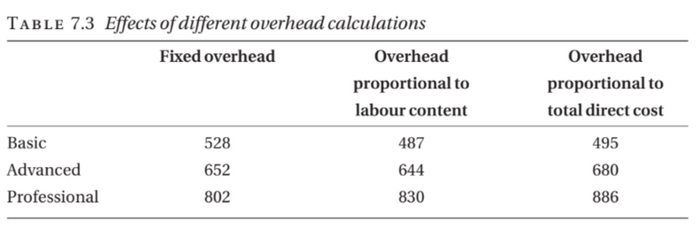

BUDGETING & CASH FLOW FORECAST – Professional Notes

1. Budgeting
Definition:
A budget is a financial plan showing the expected income and expenditure for an organization over a specific period, usually one year.

Key Points
- Owner’s Salary:
  - Owners should treat themselves as employees and pay a salary instead of living off profits.
  - Ensures proper taxation, social security contributions, and realistic business costs.
  - Example: Owner’s payroll costs = $3,000/month → $36,000/year.
- Professional Fees:
  - Businesses often require accountants for annual accounts and occasional advice.
  - Lawyers may also be needed for legal guidance.
  - Example: Accountant fees = $1,500/year; Legal fees = $1,000/year.
- Insurance:
  - Employers must legally carry insurance for employee injuries.
  - Additional insurance may cover theft, fire, or property damage.
  - Example: Employee liability insurance = $2,000/year; Theft insurance = $500/year.
Purpose of Budgeting:
- Ensures financial planning for income and expenditure.
- Helps control spending, plan for salaries, fees, and insurance.
- Useful for decision-making and obtaining finance.

2. Cash Flow Forecast
Definition:
A cash flow forecast is an estimate of money flowing in and out of a company each month, usually for 12 months, to ensure bills can be paid on time.

Key Points
- Importance:
  - A business may be profitable but still unable to pay bills if cash inflows and outflows are mismatched.
  - Staff salaries and other obligations must be met before income is received.
  - Failure to manage cash flow can lead to receivership.
- Forecasting:
  - Estimates monthly cash inflows (sales, investments, loans).
  - Estimates monthly cash outflows (salaries, rent, materials, fees, insurance).
  - Net Cash Flow = Inflows – Outflows
  - Closing Balance = Opening Balance + Net Cash Flow

Example Scenario:
- Opening Cash: $2,000
- Monthly Inflows: $10,000
- Monthly Outflows: $8,500
- Net Cash Flow = $1,500
- Closing Balance = $3,500 → business can pay bills comfortably.
Purpose of Cash Flow Forecast:
- Avoids cash shortages.
- Ensures employees and bills are paid on time.
- Helps plan borrowing or spending.

Chapter 7: Mid 2 Solved Numerical Of Overhead Cost
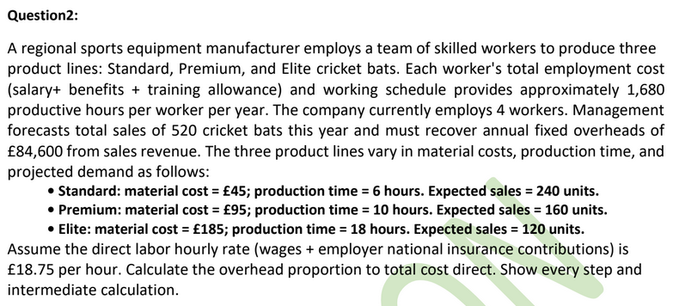

Chapter 8: Investment Appraisal

INVESTMENT APPRAISAL

Introduction

Definition
- Investment appraisal is the analysis of profitability of an investment over the life of an asset.
- Also considers:
  - Affordability
  - Strategic fit with company goals.

Why Needed
- Limited resources + many proposals → must choose the best option.

Factors to Consider
- Fit with long-term plans.
- Risk involved.
- Availability of resources (people, skills, time), not just money.
Example/Case:
- A company chooses between building a new app or upgrading servers based on profit and strategy.

Discounted Cash Flow (DCF)

What is DCF?
- A method to estimate today’s value of an investment based on its future cash flows, adjusted for time.
- Helps decide which proposal gives the best return.

Uses of DCF
- Check if a company’s share price is fair.
- Decide buy vs lease equipment.
- Compare projects.
- Decide if a capital project is worthwhile.
Example/Case:
- Compare two software projects by calculating which has higher present value.

Time Value of Money

Concept
- Money today is worth more than the same money in future.
- Because today’s money can earn interest.

Also Called
- Net Present Value (NPV) concept.
Example:
- Rs. 1,000 today is better than Rs. 1,000 after one year because today’s money can grow.

Discount Factor & Present Value

Formula
If interest rate = r, amount = X, time = t years:
PV=X(1+r)tPV = \frac{X}{(1+r)^t}PV=(1+r)tX​
- Discount factor = 1 / (1 + r)^t

Example
- Discount factor at 8% for 4 years = 0.7350
- Present value of £1,000 after 4 years:
  - £1,000 × 0.7350 = £735
Example/Case:
- Receiving £1,000 in 4 years is equal to £735 today at 8% interest.
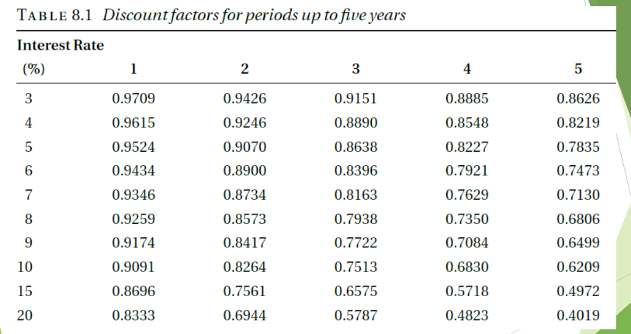

Purchasing vs Leasing (Car Example)

Given
- Car price = Rs. 10,00,000
- Lease:
  - Down payment = Rs. 2,00,000
  - Monthly = Rs. 20,000 for 60 months
Total lease cost:
- (20,000 × 60) + 2,00,000 = Rs. 14,00,000

Purchase Cost
- Rs. 10,00,000 now.

Decision?
- Leasing costs more, but must consider:
  - Interest you could earn on Rs.10,00,000 if invested.
Example/Case:
- If bank gives good interest, leasing may make sense since cash can grow.

Interest Rate

Example
- Invest Rs. 10,00,000 at 10% per year:
  - Interest = Rs. 100,000 per year
Use in DCF:
- This rate becomes discount rate for analysis.

Cost of Capital & Opportunity Cost

Cost of Capital
- The return you could earn by investing money elsewhere.

Opportunity Cost
- Benefit lost by choosing one option over another.

Key Point
- Even if you have cash, using it has a cost → lost interest.
Example/Case:
- Using Rs.10,00,000 to buy a van means losing bank interest you could earn on it.

Inflation

Meaning
- Fall in value of money over time.
- Expressed as % per year.

Example
- Inflation = 5%
- £100 today → £105 in 1 year → £110.25 in 2 years.

Handling Inflation in DCF
Steps:
- Estimate all costs in today’s money.
- Apply inflation rate to future cash flows.
- Use monetary (nominal) interest rate, not real rate.
- Simplest method in normal conditions.
Example/Case:
- Today’s cost £10,000 → becomes £10,500 next year at 5% inflation

DCF Example: Van Buy vs Hire
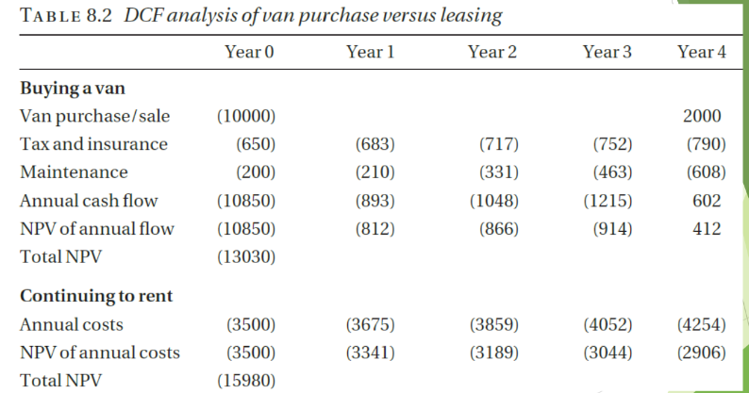

Buying Van
- Cost = £10,000.
- Annual costs: insurance, tax, maintenance.
- Resale after 5 years = £2,000.
- Discount rate = 10%.

Hiring Van
- £35 per day × 100 days = £3,500 per year.
- Subject to inflation.

Decision
- Calculate PV of both options using DCF.
- Choose lower present cost.
Example/Case:
- If PV of buying < PV of hiring → buy.

Software House Example
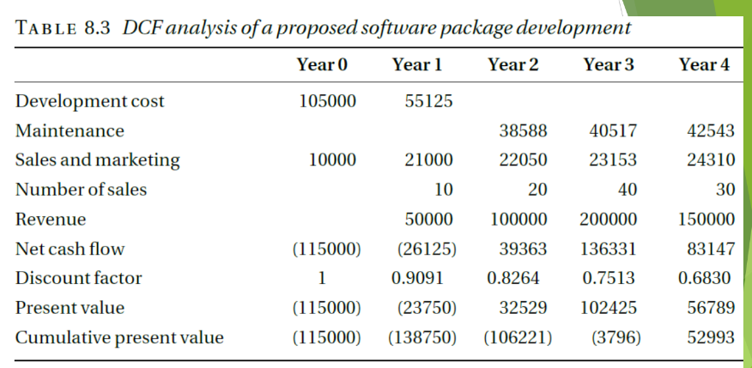

Costs
- Developers:
  - Year 1: 3 people
  - Year 2: 1.5 people
  - Cost per person = £35,000/year
- Maintenance after Year 2: 1 person full-time.
- Sales & marketing:
  - £10,000 in Year 1
  - £20,000 in Years 2–5.

Income
- 100 copies × £5,000 = £500,000 over period.

Use DCF
- Discount all costs & revenues.
- Find NPV.
Example/Case:
- If NPV positive → financially attractive.

NPV and IRR
- NPV (Net Present Value):
  - Sum of all discounted cash flows.
  - NPV > 0 → accept project.
- IRR (Internal Rate of Return):
  - Interest rate where NPV = 0.
  - Higher IRR → better return.

Pitfalls of DCF (Especially for Software)
Even if NPV = £52,993 and IRR = 23% look good:

Risks
- Software often takes more effort than expected.
- Initial versions may not work well.
- Sales may be lower than forecast.
- Competitors may launch earlier.

Best Practice
- Run DCF with different assumptions.
- Do sensitivity analysis.
Example/Case:
- Try best-case, worst-case, and likely-case cash flows to see impact on NPV.

Chapter 8: Solved Numericals
NPV,Depreciation, Payback Period
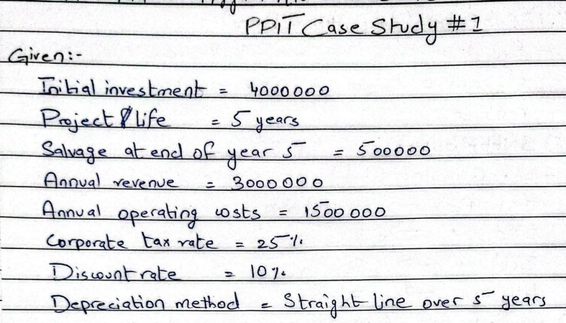
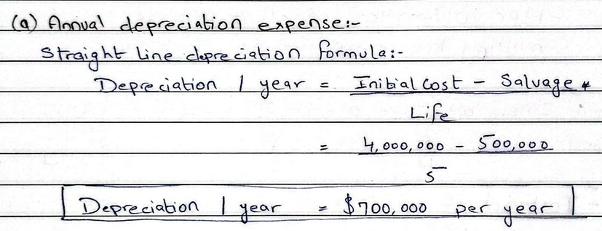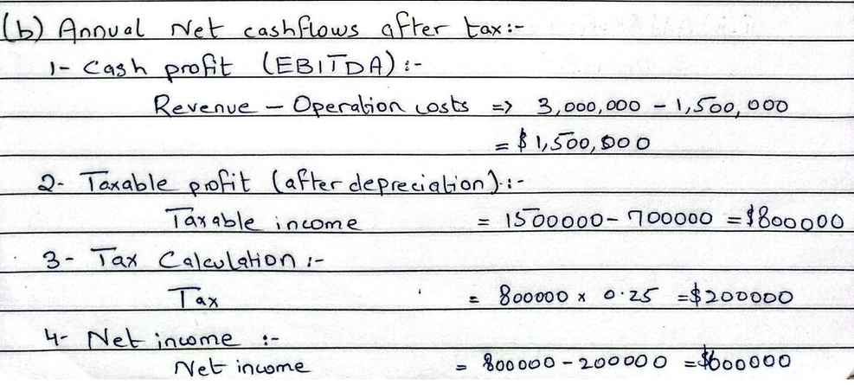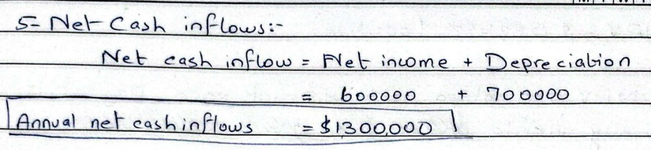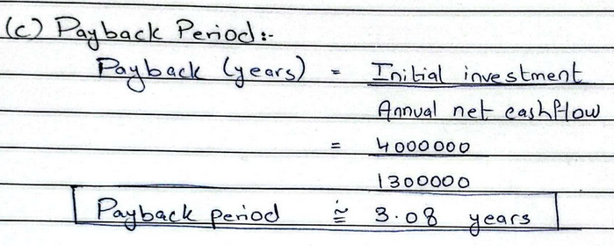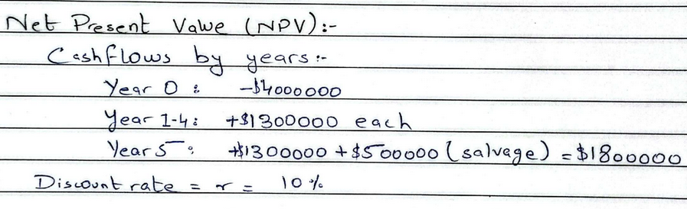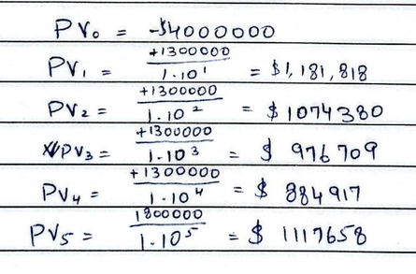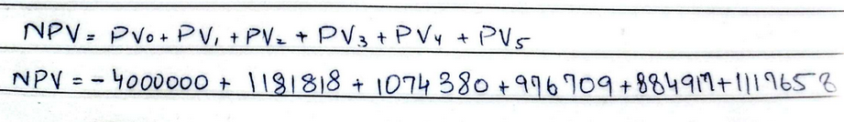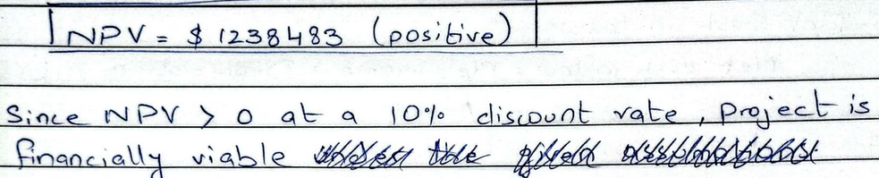

Chapter 8: Mid 2 Solved Numerical Of Purchase vs Lease
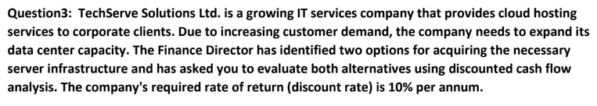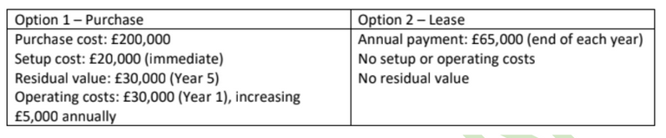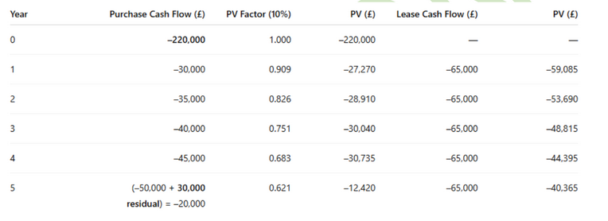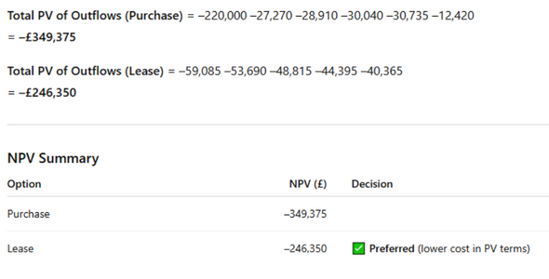

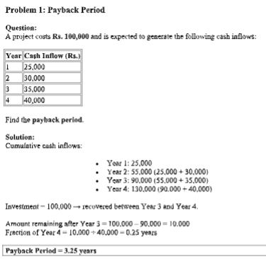

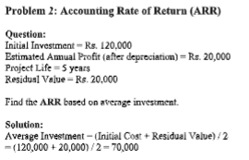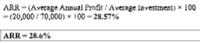

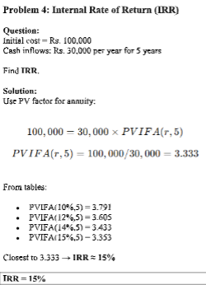

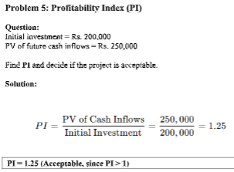

Chapter 9: Human Resources Issues

HUMAN RESOURCES ISSUES – Professional Notes

Complexity of Law in Human Resources
Human resource management operates within a complex legal framework.

Why the law is complex
- Employment law covers recruitment, pay, working hours, dismissal, equality, health & safety, etc.
- Laws are frequently updated, especially around discrimination and employee rights.
- Organizations must comply with national labor laws, court judgments, and regulations.

Example:
If a company dismisses an employee without following proper procedure, the employee may file a legal claim for unfair dismissal, costing the company fines and reputation damage.

Constraints Under Which Management and HR Staff Act
HR and management do not act freely; they operate under constraints, which include:
- Legal constraints: Must comply with employment, discrimination, and safety laws.
- Financial constraints: Limited budget for salaries, training, and benefits.
- Organizational policies: Internal rules and procedures.
- Ethical constraints: Fair treatment of employees.

Example:
Management may want to fire an underperforming employee immediately, but HR must follow disciplinary procedures required by law.

Why Managers Must Be Aware of HR Issues
Managers interact directly with employees and therefore must understand basic HR principles.

Reasons
- To avoid legal violations.
- To manage staff fairly and consistently.
- To maintain team morale and productivity.
- To reduce employee turnover.

Example:
A manager who understands discrimination laws will avoid biased promotion decisions, protecting the organization from lawsuits.

Human Resources – Core Concepts

What is a Resource?
A resource is anything an organization uses to achieve its objectives
(e.g., money, equipment, technology, people).

What is a Human Resource?
Human resources are the people who work for an organization.
They are:
- An indispensable resource
- Often the most important resource

Example:
A software company’s success depends more on its developers’ skills than on its computers.

Why Organizations Need Human Resources Management
Any organization employing staff faces administrative and people-related issues.

Key Reasons
- Managing recruitment, contracts, salaries, leave.
- Recruitment is expensive.
- High staff turnover leads to loss of experience and continuity.
- Maintaining employee motivation and loyalty.

Because of this, organizations often need:
- A full-time HR manager or personnel officer.

Example:
Replacing a senior employee may cost months of recruitment and training, making retention crucial.

Teamwork Concept
TEAM = Together Everyone Achieves More
- HR promotes teamwork and collaboration.
- Effective teams improve productivity and morale.

Example:
A project team with good HR support (clear roles, conflict resolution) delivers faster and with higher quality.

The Legal Context of Human Resources

Historical Background (UK context)
- In the 20th century, industrial relations focused on trade unions vs employers.
- Collective bargaining was dominant.
- Strikes were commonly used as a negotiation tool.
- Trade union rights had more focus than individual employee rights.

Modern Shift
- Greater emphasis on individual employee rights.
- Strong anti-discrimination legislation.
- Increased workload for HR departments.
Example:
Earlier, unions negotiated pay rises collectively. Today, individuals can sue employers directly for discrimination.

Individual Employees and Trade Unions
- HR must manage relationships with individual employees and sometimes unions.
- Balance between organizational goals and employee rights is essential.
Example:
An employee may file a grievance individually instead of through a union.

Human Resources Activities (Core Functions)
HR departments perform the following tasks to ensure the organization has the right workforce:

Recruitment & Equality
- Ensure recruitment, selection, and promotion comply with anti-discrimination laws.

Training & Development
- Improve employee skills and career growth.

Remuneration
- Set and monitor pay and benefits policies.

Appraisal
- Design and monitor performance appraisal systems.

Human Resources Activities (Continued)
- Administer dismissal and redundancy procedures legally.
- Manage contracts of employment.
- Workforce planning (right people, right time).
- Handle grievance procedures.
- Monitor new employment legislation and advise management.
- Deal with health and safety issues.
- Administer consultative committees for employee input.

Example:
If new minimum wage laws are introduced, HR ensures salaries are updated to remain compliant.

RECRUITMENT AND SELECTION – Professional Notes

Recruitment vs Selection

Recruitment
- Process of soliciting applications from potential candidates.
- Focuses on attracting suitable applicants.
- Often handled by recruitment agencies.

Selection
- Process of choosing which applicants receive job offers.
- Final decision remains with the employer.
- Recruitment agencies may advise, but cannot decide.

Example:
A company advertises a software developer role (recruitment). After interviews and tests, it selects one candidate and makes an offer (selection).

Selection Tools
Organizations use multiple tools to make professional appointments.

One-to-One Interviews
- Conducted with senior management or technical staff.
- Allows in-depth evaluation of skills and attitude.

Example:
A senior developer interviews a candidate to test technical expertise.

Panel Interview
- Multiple interviewers interview the candidate together.
- Common in the public sector.
- Can favour smooth talkers over skilled candidates.
- Considered unreliable.

Example:
A government job interview with 5 panel members asking questions.

Assessment of References
- Very important for academic and public sector roles.
- Past employers or professors provide feedback.

Example:
A university checks references before hiring a lecturer.

Psychometric Tests
Used to assess mental and behavioral traits.
Types:
- Ability tests: Measure skills (numerical, verbal).
- Aptitude tests: Measure potential to learn.
- Personality tests: Assess behavior and interpersonal traits.

Example:
An aptitude test to check if a trainee can learn programming quickly.

Situational Assessment
- Candidates face real-time simulated situations.
- Most expensive method.
- Common in military officer selection.

Example:
Army candidates given a leadership crisis simulation.

Task Assessment
- Candidates perform job-related tasks.
- Small tasks are manageable; large tasks often fail.
- Considered unfavourable.
Example:
A programmer solves a short coding task but struggles with a full project.

STAFF TRAINING AND DEVELOPMENT

Definition
Training and development include:
- Training
- Education
- Development

Aim: Improve individual and organizational performance.
Also known as:
- Human Resource Development (HRD)
- Human Capital Development
- Learning and Development

Importance
- Crucial in high-technology companies.
- Skills become outdated quickly.
- Poor training can threaten company performance.

Example:
An IT firm failing to train staff in new technologies loses competitiveness.

Common Issue
- Often the first activity that is cut when budgets are tight.
- This can cause long-term damage.

REMUNERATION POLICIES AND JOB EVALUATION

Remuneration
- Compensation received for work performed.
- Includes:
- Salaries / wages
- Bonuses
- Benefits (insurance, pensions, perks)

Job Evaluation
- Used to grade and scale jobs fairly.
- Determines relative value of jobs.
Example:
A senior engineer is paid more than a junior engineer based on job evaluation.

APPRAISAL SCHEMES (Performance Appraisal)

Definition
Performance appraisal is the systematic evaluation of an employee’s job performance.

Need for Appraisal
- Measure performance
- Identify training needs
- Plan career development
- Link performance with rewards

Appraisal Process
- Involves appraiser and appraisee.
- Meetings held:
- Every 6 months
- Annually
- Sometimes every 2 years
- Discussion covers:
- Performance
- Strengths & weaknesses
- Career development

Outcome
- Written report
- Signed by both parties
- Disagreements recorded if unresolved

Appraiser
- Usually the line manager.
- Has the best knowledge of employee’s work.

Management by Objectives (MBO)
- Developed by Peter Drucker (1970s).
- Popular in industry and government (1980s).
- Based on goal setting.

Key Idea
- Manager and employee agree on:
- Clear
- Measurable
- Verifiable objectives
- The time period is usually 6 months.

Example:
“Complete 3 projects with zero critical bugs in 6 months.”

REDUNDANCY AND DISMISSAL

Redundancy
- Termination due to business changes, not employee fault.
- Examples:
- Company downsizing
- Automation
- Business closure

Dismissal
- Termination due to employee reasons.

Valid Reasons for Dismissal
- Lack of capability
- Misconduct
- Breach of law

Constructive Dismissal
- Employee resigns due to employer’s unacceptable behavior.

Example:
Employers make work conditions unbearable, forcing resignation.

Unfair vs Wrongful Dismissal

Unfair Dismissal
- Employee dismissed without valid reason.

Wrongful Dismissal
- Dismissal may be fair, but contract terms are violated.

Example:
Employee dismissed fairly but without required notice → wrongful dismissal.

TAKEOVERS AND OUTSOURCING

Effect on Employees
When an undertaking (business) changes ownership:
- Employees of the previous employer automatically become employees of the new employer.
- Employment continues on the same terms and conditions.
- It is treated as if the contract was originally made with the new employer.
- Continuity of employment is preserved.
- All contractual rights are retained except certain occupational pension rights.

Example:
Company A is taken over by Company B. All employees of Company A continue working under Company B with the same salary, role, and benefits.

Employee Rights During Transfer
- Employee representatives have the right to be informed about the transfer.
- They must be consulted about any changes affecting employees.
- Applies to both old and new employers.

Example:
Before outsourcing IT services, management must inform staff and consult them about changes such as relocation or role modifications.

PUBLIC INTEREST DISCLOSURES (WHISTLEBLOWING)

Public Interest Disclosure Act 1998 (PIDA)
PIDA protects workers who raise concerns about:
- Criminal behavior
- Civil offenses
- Miscarriages of justice
- Health and safety dangers
- Environmental damage
- Attempts to cover up wrongdoing

Whistleblowing
Definition:
Whistleblowing is when a person (usually an employee) reveals illegal, unsafe, unethical, or fraudulent activity within an organization.

A whistleblower:
- Reports unsafe or illegal workplace conditions
- Is legally protected from retaliation or victimization

Example:
An employee reports unsafe machinery conditions to authorities and is protected from being fired.

Legal Protection
- Employers cannot punish whistleblowers for protected disclosures.
- Protection applies to injuries, safety issues, and legal violations.

CONTRACTS OF EMPLOYMENT

What is a Contract?
- A written agreement between employer and employee.
- Legally enforceable in a court of law.

Characteristics of a Good Contract
- Written in clear, simple language.
- Avoids legal ambiguity and conflict.
- Should be understandable without legal advice.
- Must be read carefully before signing.

Example:
A contract clearly stating job role, salary, working hours, and notice period reduces disputes.

HUMAN RESOURCE PLANNING

Definition
Human Resource Planning ensures the organization has the right number of staff with the right skills at the right time.
It involves forecasting future staffing needs.

Importance
- Prevents staff shortages or excess.
- Supports project planning.
- Reduces recruitment costs.

Inputs to HR Planning (Software House Example)
- Human resource plans from existing projects
- Staff required for ongoing work.
- Sales forecasts
- Expected new projects and workload.
- Forecasts of staff losses
- Expected resignations or retirements.

Example:
If sales forecasts show growth and staff losses are expected, HR plans early recruitment.

Chapter 10: Equality, Diversity & Inclusion

DISCRIMINATION – Professional Notes

What is Discrimination?
Discrimination means treating one person or group less favorably than another because of personal characteristics, rather than merit or ability.
Discrimination can be:
- Direct
- Indirect
Example:
Refusing to hire someone because of their gender or religion rather than their skills.

Grounds of Discrimination
Many countries (Europe, USA, etc.) legally prohibit discrimination on the following grounds:
- Sex / Gender
- Race, color, ethnic origin, nationality
- Disability
- Sexual orientation
- Religion
- Age
Example:
Rejecting a qualified candidate solely because they are over 50 years old is age discrimination.

Direct Discrimination

Definition
Direct discrimination occurs when a person is treated less favorably explicitly because of a protected characteristic such as sex or race.

Key Feature
- Clear and intentional
- Easy to identify

Examples
- A woman doing the same job as a man but being paid less.
- A doctor refusing to treat a Chinese patient but accepting an English patient.
- A company rejecting all male applicants for a secretary role.
- Job advertisements stating:
- “A mature woman for personal assistant”
- “A strong young man as trainee zoo-keeper”
Why it is unlawful:
Decisions are based on personal characteristics, not job requirements.

Indirect Discrimination

Definition
Indirect discrimination occurs when a rule or condition applies to everyone but disadvantages a particular group more than others.

Key Feature
- Appears neutral
- Has unequal impact

Examples
- Height Requirement
- Job requires applicants to be at least 180 cm tall.
- Disadvantages women, as fewer women meet this height.
- Housing Allocation Policy
- Priority given to children of existing tenants.
- Disadvantages newcomers unfairly.
- Saturday Work Requirement
- Mandatory Saturday work affects Jews who observe the Sabbath.
- Considered religious discrimination, possibly racial discrimination.

Justification of Indirect Discrimination
Indirect discrimination may be lawful if:
- The employer proves a genuine occupational requirement.
- The condition is necessary and proportionate.

Example:
Requiring firefighters to meet physical fitness standards may be justified.

Discrimination on Grounds of Gender (Historical Context)
Historically, women faced systematic gender discrimination:

Common Practices
- Women paid lower salaries than men.
- Men received extra allowances, especially if married.
- Married women were forced to leave jobs or accept temporary roles.
- Women were not allowed to return to work after childbirth.
- Limited access for women to medicine, law, and academia.

Impact:
Women were prevented from reaching senior and leadership positions.

Modern Perspective
- Gender discrimination is now illegal in most countries.
- Laws promote equal pay, equal opportunity, and workplace fairness.
- Employers must ensure non-biased recruitment and promotion.

ACTS OF PARLIAMENT & DISCRIMINATION LAW – Professional Notes

Acts of Parliament (UK Context)
In the UK, discrimination law changed significantly due to two key Acts of Parliament:
- Equal Pay Act 1970
- Sex Discrimination Act 1975
These Acts strengthened legal protection against discrimination and promoted equality in employment, education, and services.

Key Features of the Law (Overview)
The law covers discrimination in three main areas:
- Employment
- Education
- Provision of Goods and Services

ACTS OF PARLIAMENT – REGARDING EMPLOYMENT

Recruitment and Employment Terms
- It is unlawful to discriminate on grounds of sex or marital status:
- During recruitment and selection
- In the terms on which employment is offered

Example:
Offering a lower starting salary to a woman than a man for the same role is unlawful.

Promotion, Training, and Benefits
- Employers must not discriminate in:
- Promotion opportunities
- Transfers
- Training
- Employment benefits

Example:
Denying leadership training to women employees only is illegal.

Dismissal and Redundancy
- It is unlawful to discriminate based on sex or marital status in:
- Dismissal
- Redundancy decisions

Example:
Selecting married women first for redundancy is discriminatory.

Victimization
- Employers must not victimize employees who:
- File a discrimination complaint
- Support another employee’s complaint

Example:
Demoting an employee for testifying in a colleague’s discrimination case is illegal.

Other Organizations Covered
It is unlawful for the following to discriminate on grounds of sex or marital status:
- Trade unions
- Professional bodies
- Registration authorities
- Employment agencies
- Vocational training providers

ACTS OF PARLIAMENT – REGARDING EDUCATION

Admissions and Access
- Education providers (schools, colleges, universities) must not discriminate based on sex:
- During admissions
- In access to courses
- In facilities and benefits

Example:
Refusing women admission to an engineering course is unlawful.

Exceptions
- Single-sex institutions are allowed.
- Physical education provision may differ by sex.

Example:
Separate sports classes for males and females are permitted.

ACTS OF PARLIAMENT – REGARDING PROVISION OF SERVICES

Goods, Facilities, and Services
- It is unlawful to discriminate based on sex in:
- Hotels and accommodation
- Entertainment and recreation
- Banking and insurance services

Example:
Refusing hotel accommodation to a woman without justification is illegal.

Property
- Discrimination in selling or letting property on grounds of sex is unlawful.

Exceptions
- Charities supporting a specific sex-based group are exempt.

Example:
A charity exclusively helping single mothers is allowed.

REMEDIES FOR DISCRIMINATION

Employment Tribunal
- Victims can bring cases to an employment tribunal.
- If successful, the tribunal can:
- Award damages
- Issue recommendations to respondent
If recommendations are ignored:
- Damages may be increased

Example:
A company ignoring tribunal orders may face higher compensation penalties.

DISCRIMINATION ON RACIAL GROUNDS

Legal Basis
- Governed by the Race Relations Act 1976 and later amendments.

What the Law Prohibits
- Discrimination based on:
- Race
- Color
- Ethnic origin
- Nationality
- Recognizes direct and indirect racial discrimination.

Commission for Racial Equality (CRE)
- Established to promote racial equality.
- Formed by merging:
- Race Relations Board
- Community Relations Commission

Role:
Investigate discrimination and promote equality practices.

DISCRIMINATION ON GROUNDS OF DISABILITY

Government Approach (Since 1970s)
- Encouraged recruitment of disabled employees into:
- Civil Service
- Private sector

Enforcement Measures
- Government contracts withheld from companies that:
- Fail to demonstrate commitment to employing disabled workers

Example:
A company loses government contracts for refusing reasonable workplace adjustments.

DISABILITY DISCRIMINATION ACT 1995 – Professional Notes

Purpose of the Act
The Disability Discrimination Act (DDA) 1995 makes it unlawful to treat a disabled employee or job applicant less favorably because of their disability without justification.

Justification
- Any justification must be serious and substantial.
- Discrimination is only lawful if the disability makes it impossible or unsafe to perform the job.

Examples (Justified Discrimination):
- Rejecting a blind applicant for a bus driver role.
- Rejecting a paraplegic applicant for a lifeguard position.

Key Point for Exams:
Disability alone is not enough to justify discrimination — it must be directly related to job requirements.

DISABILITY & WEB ACCESSIBILITY – SURVEY FINDINGS

Disability Rights Commission Survey
The Disability Rights Commission commissioned a study titled:
“The Web: Access and Inclusion for Disabled People”

Key Findings
- Surveyed 1,000 home pages
- 81% failed to meet even the lowest W3C accessibility standards
- Many failures were on government websites

2. Common Accessibility Problems
- Confusing and unclear page layout
- Disorienting navigation mechanisms
- Poor contrast between text and background
- Inappropriate use of color
- Text and graphics too small
- Poorly labeled links and images
- Incompatibility with assistive technologies:
- Screen readers
- Magnification software

Example:
A blind user cannot access a government website because images lack text descriptions.

DISCRIMINATION ON GROUNDS OF RELIGION, BELIEF & SEXUAL ORIENTATION

Legal Framework (UK)
EU directives were implemented in the UK through:
- Employment Equality (Sexual Orientation) Regulations 2003
- Employment Equality (Religion or Belief) Regulations 2003
Effective from December 2003.

These follow the model of:
- Sex Discrimination Act 1975
- Race Relations Act 1976

Scope of the Regulations
They apply to discrimination in:
- Employment
- Education
- Related matters

They do NOT cover:
- Provision of services
- Accommodation

Harassment (Explicitly Unlawful)
Harassment is defined as:
“Unwanted conduct that violates a person’s dignity or creates an intimidating, hostile, degrading, humiliating, or offensive environment.”
This was explicitly defined for the first time in these regulations.

Example:
Making offensive jokes about an employee’s religion constitutes unlawful harassment.

Equality Bodies
- No new body was created to enforce these regulations.
- In October 2003, the UK government announced plans for a single equality body to replace:
- Equal Opportunities Commission
- Commission for Racial Equality
- Disability Rights Commission

DISCRIMINATION ON GROUNDS OF AGE

Equal Treatment Directive
The law allows age discrimination in specific justified cases.

Permitted Age-Based Treatment
Age discrimination is allowed when reasonable and justified, including:

Protection of Age Groups
- Preventing employment of children under a certain age.

Insurance and Pensions
- Different life insurance premiums based on age.
- Different pension rates depending on retirement age.
- Must not involve sex discrimination.

Recruitment Age Limits
- Maximum age set to ensure:
- Adequate working period after training
- Before retirement

Minimum Experience Requirements
- Minimum age or years of experience for promotion or benefits.
- Examples:
- Extra annual leave after 5 years
- Senior roles requiring prior experience

Example:
Requiring 10 years’ experience for a senior management role is lawful.

AVOIDING DISCRIMINATION IN THE WORKPLACE
Effective compliance requires three key elements:

Written Policy
- Clearly written
- Well publicized
- Easily accessible to all staff

Training
- For new employees
- Refresher training for existing staff
- Emphasizes importance of equality

Effective Procedures
- Clear reporting mechanisms
- Fair investigation processes
- Consistent enforcement

Example:
A company with anti-discrimination training and complaint procedures reduces legal risk.

Chapter 11: Intellectual Property

What is Intellectual Property?

Tangible vs Intangible Property
- Tangible property: Physical items (bike, computer). If stolen, the owner loses it.
- Intellectual property (IP): Intangible ideas/information (software, formulas, designs).
If copied, the owner still has it, but others can also use it.
Therefore, IP needs special legal protection.

Definition
Intellectual Property = creations of the mind protected by law, giving rights to use, copy, or disclose.

Why is it important in IT?
- Software is intangible.
- Companies protect code, designs, ideas using IPR laws.

Example:
A company writes an app. If someone copies the code, the company still has it, but loses its business advantage → copyright protects it.

International IP Laws
- Paris Convention (1883) → Trademarks & Patents.
- Berne Convention (1886) → Copyright.

Types of Intellectual Property Rights
- Copyright – protects expression (books, music, software).
- Patents – protect inventions.
- Confidential Information – protects secrets shared in trust.
- Trademarks – protect brand names/logos.

Game Example – “Spookcatcher”:
- Game code → Copyright
- Wailer device → Patent
- Ghost logo/name → Trademark
- Performance data structures → Confidential info

COPYRIGHT

What is Copyright?
Right to control conditions under which original work may be copied.

The work includes:
- Literary (includes software, code, databases)
- Artistic, musical, etc.
Comes into existence automatically when recorded.
No registration required.

What is protected in software?
- Source code
- Object code
- Design material
- Databases (if original)

Rights of the Copyright Owner
Copyright law gives the owner of the copyright the following rights:
- Copy the work (even loading into RAM counts).
- Distribute copies to the public.
- Lend the work to the public
- Perform, play or show the work to the public
- Broadcast the work to the public
- Make an adaptation (translation, modification, conversion into a different language) of the work

Duration: 70 years after author’s death.
Important:
Copyright does not stop others from independently creating the same thing if not copied.

Example:
Two programmers separately write the same algorithm. No infringement if no copying.

What You Are Allowed To Do
You may:
- Make one backup copy.
- Decompile to fix errors or ensure interoperability.
- Resell your copy (but must delete yours).

Example:
You reverse engineer a file format so your software can read it → allowed if no other way.

Copyright Case Studies

Authors Guild v. Google (2015)
- Google scanned books for search.
- Court: Fair use – transformative, helps discovery.

Google v. Oracle (2021)
- Google reused Java APIs for Android.
- Court: Fair use – transformative platform.

Lesson:
Transformative use for public benefit may be fair use.

Databases & Database Right
- Copyright applies if the database is an intellectual creation.
- Many databases need effort but little creativity → Database Right (1997).

Exists if there is substantial investment.
- Lasts 15 years.
- Prevents extraction/reuse of substantial parts.

Example:
Hotel listings database built with effort → protected even if not creative.

Copyright Infringement
Infringement – action of breaking terms of law or agreement

Types of Infringement of Copyright:
- Primary Infringement:
- Directly doing restricted acts without permission and consent. Can be committed by accident
- Civil case → damages or injunction.
- Secondary Infringement
- In business context (selling/using pirated software).
- Can be criminal → fines or prison.

Example:
Company installs pirated Windows on all PCs → secondary infringement.

Platforms Example
YouTube hosting pirated videos → liable if aware and not removing.

Ownership of Copyright
- Normally → author owns it.
- Joint authors → joint ownership.
- If created by an employee at work → employer owns.
- If by freelancer → freelancer owns unless contract says otherwise.
Always use written contracts.

Example:
Startup hires freelancer to code app without contract → freelancer owns copyright.

Licensing
- The owner keeps copyright.
- Others get rights via license

Example:
Microsoft licenses Windows to users but still owns it.

PATENTS

What is a Patent?
State-granted temporary monopoly to stop others exploiting an invention.

Must be applied for.
Stronger than copyright: stops even independent inventors.

Why Do Patents Exist?
- Encourage invention.
- Force disclosure.
- Allow inventors to:
- Recover costs.
- License invention.
- Block competitors.

What Can Be Patented? (4 Conditions)
- New – not known before.
- Inventive – not obvious.
- Useful – industrial use.
- Allowed – not excluded.

What Is Excluded?
Cannot patent:
- Scientific theories.
- Mathematical methods.
- Artistic works.
- Presentation of information.
- Business methods.
- Computer programs as such.

Example:
Gravity law → no.
New machine using gravity → yes.

Obtaining & Enforcing Patents
- Apply via national offices.
- Costly, takes up to 4 years.
- Often need a patent attorney.
- Must prove no prior art.
Enforcement:
- Legal battles.
- Expensive and slow.
Example:
Small startup owns patent but cannot afford to sue big company.

Software Patents

USA
Patent allowed if software:
- Part of a patentable product.
- Controls physical processes.
- Processes real-world data.

Europe/UK
- Software can be patented if it gives technical contribution.
- Not code itself, but method/system.

Copyright → code.
Patent → idea/process.

Example:
MRI machine software improving image clarity → patentable.

CONFIDENTIAL INFORMATION

Meaning
- Info shared under obligation of confidence (trust).
- Often via NDA (Non-Disclosure Agreement).
Not formal IP right, but treated similarly.
Examples:
- Unpublished invention.
- Business plans.
- Sales negotiations.
If disclosed publicly before patent → patent may be refused.

Limits & Public Interest
- Not same as general skills/experience.
- Courts may allow disclosure if in public interest.

Public Interest Disclosure Act (1998)
Protects workers who expose:
- Crime
- Legal violations
- Miscarriage of justice
- Health/safety dangers
- Environmental harm
- Concealment of above
Must be protected disclosure.
Example:
Engineer reveals unsafe software in hospital system → protected.

TRADEMARKS & PASSING OFF

Trademark
Under Trademarks Act 1994:
A sign (name, logo, shape) distinguishing goods/services.
Registered via UKIPO.
Illegal to:
- Use without permission.
- Sell/import/export fake branded goods.

Passing Off
- Using a similar look/name to mislead customers even if not registered.
- Example:
Selling “Facecook” app with similar logo → passing off.

Domain Names
- Managed by ICANN globally.
- Allocated first-come, first-served.
- Must be globally unique.
Conflict:
- Trademarks are territorial.
- Domains are global.
Example:
Two firms own same trademark in different countries → only one gets domain.

Cybersquatting
Registering famous brand as domain to sell later.
Intent: profit, mislead, damage brand.
Laws like ACPA and UDRP help recover domains.
Examples:
- Tesla.com bought back in 2016 for millions.
- MikeRoweSoft.com vs Microsoft → settled.

WIPO & Domain Disputes
- UDRP (1999) → fast dispute resolution.
- ~80% cases resolved for trademark owners.
- Harder when names are personal/geographic.

Discussion Insight

Novel vs Rocket Engine
- Novel: copyright covers text, characters, story expression, not ideas.
- Rocket engine: patent protects technical invention, not drawings alone.
Copyright = expression.
Patent = functional invention.

Chapter 12: Software Contracts & Licenses

CONTRACTS

Definition
A legal agreement between two or more people (or companies) that creates rights and duties,
and is enforceable by law. In other words:
- It’s a promise (or set of promises) between parties.
- If one party breaks it, the other can seek legal remedies (e.g. compensation, cancellation, etc.).
- Each party agrees to do or not to do something specific.

How to Write:
- Should be set out in a clear and logical manner
- should be complete and consistent
- Should have no ambiguity
- Should be free of doubts regarding the rights and duties of concerned parties

Example
A freelancer on Upwork agrees to build a website, and the client agrees to pay PKR 80,000. Work ↔ Payment = contract.

Essentials of a Valid Contract
A contract is valid only if it has:
- Offer & Acceptance – One party offers, the other accepts.
- Competent Parties – Adults, mentally capable.
- Consideration – Something of value exchanged (money, service).
- Intention to create legal relations – Both mean it to be legally binding.

Example
Company offers job → developer accepts → salary promised → both intend legal binding.

Types of Software Contracts
- Fixed Price Contract:
- A set price is agreed upon for the entire project.
- Software houses bear the risk if work takes longer than expected.
- Contract Hire:
- Client pays for the services of personnel (developers, analysts, etc.) on a temporary or contract basis.
- Time and Materials Contract
- Client pays according to the actual time spent and materials used.
- Flexible but can become costly without proper tracking.
- Consultancy Contract:
- Involves advisory or expert services rather than software development.
- Payment is often based on consulting hours or deliverables.

Structure of Software Contract
Three main sections include:
- Introductory Section:
- Defines the parties involved (names, registered addresses).
- Includes the date and authorized signatures.
- States the purpose of the agreement.
- Standard Terms and Conditions:
- Legal clauses governing payments, delays, confidentiality, ownership, liabilities, etc.
- Appendices / Annexes:
- Contain detailed technical, financial, or operational specifications.
- May include project plans, deliverable lists, or acceptance criteria.

Key contract components include:
- What is to be Produced: Must clearly specify what software or service will be developed.
  - Often uses two-level references:
    - Main deliverable (software system): “A billing system for the client’s customers.”
    - Sub-components (modules, documentation, testing, etc.): listed in appendices, e.g., “Module for user login, payment tracking, and reporting.”

- What Is to Be Delivered: Delivering software is more than just sending the program file. It includes all materials the client needs to use, maintain, and understand the software. This includes:
  - Source code
  - Command files for building the executable code from the source and installing it.
  - Documentation and Manuals
  - Test data and test results (Proof that the software was tested successfully.)

- Ownership of Rights: Specifies who owns the intellectual property (IP). Defines whether the client gets full ownership, limited license, or usage rights only.

- Confidentiality: Ensures that client information and project data remain private.
  - prohibits sharing information with unauthorized persons, including co-workers or outsiders.

- Payment Terms: it defines:
  - Payment schedule (e.g., milestone-based, monthly, or on delivery).
  - Penalties for late payment or project delays.
  - Example: “Payment shall become due within 30 days of the invoice date. If payment is delayed beyond this period, the company may apply a 2% surcharge or terminate the contract.”
- Calculating Payments for Delays and Changes: Contracts should include a mechanism for compensating wasted efforts due to changes in requirements or delays.
  - The method of calculating additional payments must be clearly defined.

- Penalty Clauses: Applied when the supplier causes project delays or fails to meet delivery terms.
  - Typically involve monetary fines or reductions in payment.

- Obligations of the Client:
  - The client must:
    - Provide necessary information, resources, or access for the project.
    - Respond to queries or feedback in a timely manner.
    - Ensure payment as per the contract.
    - Cooperate with the development team to enable smooth completion.
- Other Common Sections:

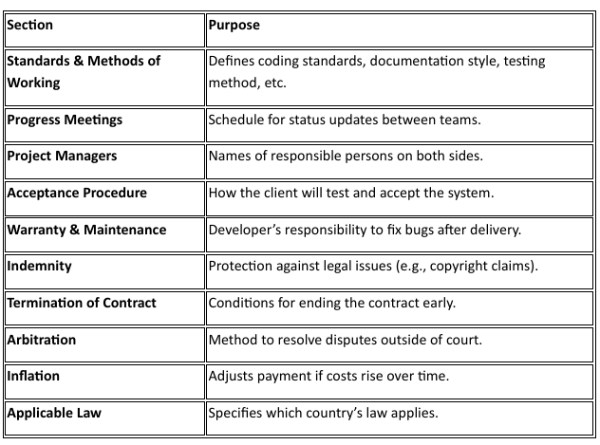

Contract Hire
Contract Hire: agreement means a client hires people (like programmers, analysts, or
designers) from a software company for a specific period and pays based on time, not
Results.
- The supplier (software company) only provides skilled workers; not full responsibility for the project’s success.
- Example: A company hires a developer from a software firm for 3 months to assist its in-house team. The payment is based on hours worked, not on project completion.

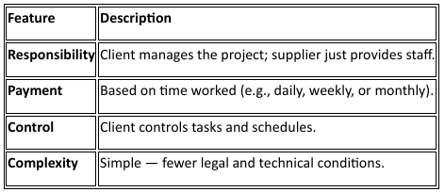

Time and Materials (T&M) Contracts
Time and Materials (T&M) Contracts: A hybrid between contract hire and fixed-price contracts
- Nature: The supplier agrees to develop the software like a fixed-price project, but payment depends on actual costs incurred.
- Payment includes:
- Labor cost (similar to contract hire)
- Material cost (e.g., tools, licenses, or hardware used)
- Pros:
- Flexible — allows the client to modify scope as the project progresses.
- Cons:
- Cost can increase if project scope is unclear or expands over time.
- Example: A company hires a developer to build an inventory system. Rate = £40/hour + cost of any licenses. If it takes 100 hours and £200 in licenses → total = £4,200.

Consultancy Contracts
Consultancy Contracts: is for hiring an expert or advisor to provide advice, analysis, or
recommendations, not necessarily to develop software.
- Consultants are often hired:
- To assess an organization’s IT systems
- To recommend software solutions
- To assist in project planning or technology selection
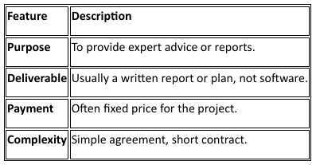
- Example: A hospital hires an IT consultant for £5,000 to advise on a new electronic medical record system. The consultant studies their current setup and submits a detailed report with recommendations.

Liability for Defective Software
We're talking about who is legally responsible if the software doesn’t work properly; that is, if it has defects, bugs, or fails to meet what was promised in the contract.

- General Law on Product Quality: In most countries, laws protect consumers by requiring that products sold must meet certain quality standards. These laws say that the goods or products supplied must be:
  - State and condition: (the product must function properly)
  - Fitness for purpose (it should do what it’s supposed to)
  - Freedom from defects (no minor or major faults)
  - Safety (should not cause harm or risk)
  - Durability (should last a reasonable period)

- What the Law Currently Says: Since software is often treated as a service, the only clear legal standard is: “It must be written with reasonable skill and care.”
  - This means the Developer must have the knowledge and ability to create the software properly (skill) and must follow good practices (testing, documentation, quality checks) (care)
  - Physical products have clear quality standards.Hence software, being intangible, is harder to evaluate the same way.

- Guarantee Clauses: To avoid legal uncertainty and avoid the goods and service confusion, contracts often include guarantee (warranty) clauses. These clauses clearly define:
  - What happens if the software is defective?
  - What level of support or correction the supplier must provide.
  - Whether the client is entitled to compensation or maintenance services.

Chapter 13: Data Protection, Privacy & Freedom of Information

Background
- Public concern arose when large amounts of personal data were collected and used in ways that were:
- Different from the purpose for which the data was collected
- Potentially unacceptable or unethical
- Key concerns included:
- Unauthorized access to data
- Inaccuracy or incompleteness of data
- Misuse for unintended purposes

DATA PROTECTION ACT 1984
- Passed in the UK to implement the Council of Europe Convention on Data Protection
- Designed to protect individuals against:
- Use of inaccurate, incomplete, or irrelevant information
- Use of personal data by unauthorized persons
- Use of personal data for purposes other than originally collected

Key Responsibilities include:
- Prevent misuse of personal data by large organizations, public or private
- Example:
- Credit card data used via data-matching to track a person’s movements
- Credit rating agencies making incorrect lending decisions based on others’ defaults

Evolution of Data Protection
- Mid-1990s: Rise of the internet enabled profiling of user habits, leading to marketing or potentially sinister uses (e.g., blackmail)
- 1995: European Directive on Data Protection
- 1998: UK Data Protection Act replaced the 1984 Act

DATA PROTECTION ACT 1998
- Updates the 1984 Act to reflect modern digital concerns
- Introduces the following key terminologies:
Term | Definition
Data | Information processed automatically or recorded for automated processing or as part of a relevant filing system
Data Controller | Person or organization (natural or legal) who determines why and how personal data is processed
Data Processor | Anyone processing personal data on behalf of the controller who is not an employee (e.g., online booking service provider)
Personal Data | Data relating to a living person who can be identified from that data or combined information
Data Subject | Individual who is the subject of personal data
Sensitive Personal Data | Personal data regarding:  - Racial or ethnic origin  - Political opinions  - Religious beliefs  - Trade union membership  - Physical or mental health  - Sexual life  - Criminal offences or allegations  Stricter processing rules apply |

Processing
Processing means obtaining, recording, holding, or operating on data, including:
- Organization/alteration/adaptation of data
- Retrieval, consultation, or use of data
- Disclosure by transmission, dissemination, or making available
- Alignment, combination, blocking, erasure, or destruction of data

DATA PROTECTION PRINCIPLES (1998 Act)
- The Act sets eight principles governing the collection and processing of personal data.
- Schedule: appendix/section at the end of an Act, explaining how and when the Act is allowed
- Data controllers are responsible for ensuring compliance.

Eight principles are:

Lawfulness (Fair and Lawful Processing)
- Personal data must be processed fairly and lawfully.
- Conditions under Schedule 2 must be met, e.g., consent from the data subject or a legal/statutory obligation.
- For sensitive data, Schedule 3 requires explicit consent.

Purpose Limitation
- Data must be collected for specified, lawful purposes only.
- Data cannot be used in ways incompatible with those purposes.
- Notification to the Information Commissioner is required for collected data and its purposes.

Data Minimisation
- Data must be adequate, relevant, and not excessive in relation to the purpose.

Accuracy
- Data must be accurate and, where necessary, kept up to date.
- Challenges: Frequent address changes of students, patients, or transient populations.

Storage Limitation
- Data must not be kept longer than necessary for its intended purpose.
- Considerations:
- Legal obligations (e.g., financial records for 7 years)
- Civil claims (6-year limitation period)
- Some records may be kept indefinitely (e.g., university graduation records)
- Erasure procedures (including backups) must be implemented.

Rights of Data Subjects
- Processing must respect the rights of individuals under the Act, e.g., access to their data, correction requests, etc.

Security
- Implement technical and organizational measures to prevent:
- Unauthorized or unlawful processing
- Accidental loss, destruction, or damage
- Examples:
- Password protection & access control
- Backups and integrity checks
- Vetting personnel with data access

Overseas Transfer
- Data must not be transferred outside the European Economic Area (EEA) unless the destination ensures adequate protection of rights and freedoms.

- Purpose:
- Protects data subjects from misuse abroad
- Allows cross-border business if adequate safeguards exist

RIGHTS OF DATA SUBJECTS
Under the 1984 Data Protection Act:
- Right to know whether a data controller holds personal data about them.
- Right to see the data.
- Right to have inaccurate data corrected or erased.

Under the 1998 Data Protection Act, these rights were extended:
- Right to receive:
- A description of the personal data held.
- The purpose for which data is processed.
- The people or organizations to whom data may be disclosed.
- An intelligible statement of the data about them.
- A description of the data source.
- Right to prevent processing likely to cause damage or distress.
- Right to prevent processing for direct marketing.
- Right to compensation for damage caused by unlawful processing.

Scope & Exceptions:
- Right of access may be restricted if:
- Disclosing would infringe another person’s rights.
- Data is a reference given by the controller.
- Examination candidates’ marks or recorded answers during exams are exempt.

PRIVACY
Regulation of Investigatory Powers Act 2000 (RIPA):
- Framework for lawful interception of computer, telephone, and postal communications.
- Allows government security and law enforcement agencies to monitor data only in specific circumstances, e.g.:
- Preventing/detecting crime.
- Investigating unauthorized use of systems.
- Ensuring effective system operation (e.g., detecting viruses or DoS attacks).

- Organizational monitoring:
ISPs, telecom providers, and employers can monitor communications without consent if done for:
- Establishing facts (e.g., date of a transaction).
- Ensuring compliance with regulations/procedures.
- Detecting or preventing crime (including cybercrime).
- Distinguishing business vs private communications.
- Monitoring confidential helplines (anonymously if required).

FREEDOM OF INFORMATION (FOI)
Purpose: Grant public access to information held by public sector bodies.

Scope i.e. bodies covered by the Act:
- Applies to Parliament, government departments, local authorities, health trusts, schools, universities, etc.
- Anyone can request information, with enforcement mechanisms if access is denied.

Key Features:
- General right of access to information held during public functions, subject to conditions and exemptions.
- Public authorities must disclose exempted information if public interest outweighs the exemption.
- Creation of:
- Information Commissioner – oversees FOI implementation.
- Information Tribunal – enforces FOI rights.
- Duty on public authorities to adopt a publication scheme, which is approved by Information Commissioner and:
- Lists classes of information to be published.
- Specifies publication method.
- States whether information is free or fee-based.

Question 1
Which data protection principles are potentially breached when CSTC shares learners’ assessment scores with the employer without informing them? Answer:
Sharing learners’ assessment scores with an employer without informing them breaches: Lawfulness, fairness, and transparency– learners were not told about this use of their data. Purpose limitation– data collected for training was used for a different, unrelated purpose.

Question 2
The spreadsheet includes data of learners who left two years ago. Which principle does this violate and why? Answer:
Keeping data of learners who left two years ago breaches: • Storage limitation– data must not be kept longer than necessary. CSTC should have deleted or archived this data according to a retention schedule.

Question 3
Is it appropriate for all 10 administrative staff to have access to personal data? Which principle applies? Answer:
Allowing all 10 administrative staff to access all learner data breaches: • Data minimisation– only staff who need access should have it. • Integrity and confidentiality– access should be restricted to protect security.

Chapters 14 & 15: Internet Issues & Computer Misuse

Benefits of the Internet
- Information Access – The internet has made access to vast amounts of information significantly easier and faster.
- Communication – It enables efficient communication between individuals and groups across the world.
- Faster Commercial Transactions – Many types of business transactions are now simpler, faster, and more cost-effective.
- Wider Availability – These benefits are available to a large portion of the population, not just a privileged few, although universal access has not yet been achieved, even in developed countries.

Problems of Internet Availability
Every country has laws regulating what may be published or publicly displayed. The global nature of the internet creates conflicts between national laws and cross-border information flow.

Major Areas of Concern
The main problem areas arising from internet availability include:
- Defamation
- Sexual content
- Spam
- Political and religious commentary
- Depictions of violence
These issues concern not only technical professionals but also society as a whole. They involve legal, social, and cultural considerations, not just technical ones.

Differences Between Countries
Different countries regulate online content in very different ways:
- Some countries consider images of scantily clad women indecent and prohibit them in publications and advertising.
- Other countries regard such images as acceptable.
- In some states, criticism of the government or established religion is forbidden.
- In others, freedom of expression is constitutionally protected and strongly defended.
The internet itself has no geographical boundaries, making enforcement of national laws difficult.

Role of Internet Availability
- The internet (and satellite television) has made these international differences more visible and more significant.
- Material now crosses borders easily, increasing the likelihood that content illegal in one country will enter it.
- This makes enforcement of national publication laws more complex.
- Internet Service Providers (ISPs) play a central role in addressing these challenges.

Internet Service Providers (ISPs)
Key Legal Issue:
The central question is how far an ISP can be held responsible for content generated by its users.

In Europe, this is governed by:
- European Directive 2000/31/EC
- Implemented in the UK by the Electronic Commerce (EC Directive) Regulations 2002

ISP roles according to regulations:

Mere Conduit
An ISP acts as a mere conduit when it only transmits data.
Conditions when it is not liable:
- Does not initiate the transmission
- Does not select the receiver
- Does not select or modify the data transmitted
Temporary storage is permitted only as part of the transmission process.

Caching
Caching involves automatic, intermediate, and temporary storage of data to improve transmission efficiency.

An ISP is not liable if it:
- Does not modify the information
- Complies with access conditions
- Follows industry-recognized updating rules
- Does not interfere with lawful data-collection technologies
- Acts quickly to remove or disable access once it knows:
- the original content has been removed,
- access has been disabled, or
- a court or authority has ordered removal

Hosting
An ISP acts in a hosting role when it stores information provided by customers.
The ISP is not liable if:
- It had no actual knowledge of unlawful activity
- It had no reason to suspect unlawful activity (in damage claims)
- It acted promptly to remove or disable access once informed
- The customer was not acting under the ISP’s authority or control

ISP Responsibilities and Anonymity
- ISPs lose immunity if they fail to remove unlawful material after being informed.
- Online users often post content anonymously or under pseudonyms.
- ISPs know the real identities of users.

Legal Question
- Can an ISP be compelled to reveal user identities to enable legal action against a contributor?
- This remains a key legal and ethical issue in internet governance.

Law Across National Boundaries
When activities cross national borders—especially via the internet—legal complexity increases. The key legal areas involved are:
- Criminal law
- Extradition treaties
- Extraterritorial jurisdiction
- International Convention on Cybercrime
- Civil law

Criminal Law Across Borders
- Criminal Law – deals with offences against the state or society.
- The issue arises as criminal law is mostly territorial

Scenario
- Suppose a person X commits a criminal offence in Country A and then moves to Country B.
- Two legal questions arise:
- Can Country A request that X be arrested in Country B and returned for trial?
- Can Country B prosecute X for an offence committed in Country A?

Extradition
- If an extradition treaty exists between Country A and Country B, X may be extradited.
- Extradition means X is arrested in Country B and returned to Country A to face trial.

Important conditions for extradition:
- The alleged offence must be a crime in both countries (dual criminality).
- Extradition procedures are legally complex.
- Many extradition attempts fail due to procedural or technical weaknesses.

Prosecution in the Second Country
- In general, Country B cannot prosecute X for crimes committed in Country A.
- However, some countries (notably the UK and the USA) claim extraterritorial jurisdiction.

Extraterritorial Jurisdiction
Extraterritorial jurisdiction is the right of a country to prosecute its citizens or residents for crimes committed abroad.
- Most commonly applied to:
- Sexual offences involving children, committed overseas
- Broader use of extraterritorial jurisdiction:
- Is politically sensitive
- Often makes countries internationally unpopular

Internet Crime and Jurisdiction

Cross-Border Content Example
- A person in Country A publishes material online that is:
- Legal in Country A
- A criminal offence in Country B

Legal consequences:
- The person cannot be prosecuted in Country A.
- Extradition to Country B is unlikely.
- However, the person may risk arrest if they voluntarily visit Country B.
This highlights the difficulty of applying national laws to global internet activity.

International Convention on Cybercrime

Convention on Cybercrime (2001)
- Approved by the Council of Europe
- Covers crimes committed via:
- The internet
- Computer networks

Includes offences such as:
- Computer hacking
- Computer-related fraud
- Criminal copyright infringement
- Online child sexual abuse imagery

Ratification Process
- Governments sign the convention to show approval.
- The treaty has no legal force until:
- The national legislature approves it
- Necessary domestic laws are passed
- This approval process is called ratification
- International conventions are therefore slow to take effect

Civil Law Across Borders

Complex Civil Liability Example
- ISP headquartered in the USA
- European office in London
- Customer is Italian, living in Italy
- Website hosts defamatory content about a French politician
- ISP refuses to remove the content

Legal Options
The French politician could theoretically bring legal action in:
- England
- France
- Italy
- The USA
Practical reality:
- The best chance of success may be in France
- However, legal action is ineffective unless the ISP has a legal presence in that country
- The same issue applies to Italy
This demonstrates how civil claims become complex when multiple jurisdictions are involved.

Defamation

Definition:
- Defamation means:
“Making statements that damage a person’s reputation, bring them into contempt, or cause them to be disliked.”

Types of Defamation:
- Slander: spoken defamation
- Libel: written, recorded, or published defamation (including online)

Defamation – Possible Defences
A defendant may avoid liability if:
- They were not the author, editor, or publisher
- The statement is substantially true
- The statement was an opinion, and its basis was made clear
- The statement was published in the public interest
- The content was posted by a third party and the website operator was not responsible
- The statement appeared in a peer-reviewed academic or scientific journal
- The statement is protected by privilege, such as court reporting

Defamation Act 2013 (UK)
- Before 2014, a defamation claim could be brought based on damage to reputation alone.
- The Defamation Act 2013 introduced a higher threshold.

Current Requirement
- The claimant must prove “serious harm”
- For businesses, this usually means:
- Serious financial loss, or
- A likelihood of such loss
This reform aimed to reduce trivial or abusive defamation claims.

Case Study: Silk Road Dark Web Marketplace (2013)
- Silk Road was an anonymous dark web marketplace used to trade illegal goods.
- The FBI dismantled the platform using:
- Digital forensics
- Analysis of Bitcoin transactions
- Identification of hidden server locations
- Ross Ulbricht, the creator, was convicted and sentenced to life imprisonment.

Significance
- Demonstrated the effectiveness of:
- Digital forensics
- Law enforcement cooperation
- Showed that anonymity on the internet is not absolute

Internet Content Rating Association (ICRA)
The Internet Content Rating Association (ICRA) is an international, independent organization whose stated mission is:
“To help parents protect their children from potentially harmful material on the internet, while respecting content providers’ freedom of expression.”

Key Features
- ICRA focuses on content labeling and filtering, not censorship.
- It enables parents and guardians to control what content children can access.
- Its board includes representatives from major internet and communications companies, including:
- AOL
- BT
- Cable & Wireless
- IBM
- Microsoft
- Novell

SPAM

Definition
Spam can be defined as:
Unsolicited email sent without the consent of the addressee and without any attempt to target recipients likely to be interested in its content.

Technical Measures to Reduce Spam
Several technical approaches are used to combat spam, including:
- Closing security loopholes that allow spammers to:
- Hijack other people’s computers
- Relay bulk messages through compromised systems
- Using machine learning techniques to:
- Detect suspicious message headers
- Identify spam patterns
- Using virus detection software to:
- Block emails containing malware
- Maintaining block lists (stop lists) of known spam-sending sites

European Anti-Spam Legislation

Legal Framework
- Directive: European Community Directive on Privacy and Electronic Communications (2002/58/EC)
- Issued in 2002
- Required implementation by December 2003
- Implemented in the UK as:
- Privacy and Electronic Communications (EC Directive) Regulations 2003 (PECR)

Essential Features of the Directive (Email Spam)
- Consent requirement
- Unsolicited email may only be sent to individuals if they have given prior consent (opt-in model).
- Transparency requirement
- It is unlawful to send unsolicited email that:
- Conceals the sender’s identity
- Fails to provide a valid reply address for opting out
- Soft opt-in exception
- If an email address was obtained during the sale of goods or services:
- The seller may send marketing emails
- Provided the recipient is:
      - Clearly informed
      - Given an easy, free option to opt out with every message

Anti-Spam Legislation in the USA

CAN-SPAM Act 2003
- Full name:
Controlling the Assault of Non-Solicited Pornography and Marketing Act
- Came into force in January 2004

Weaknesses of the CAN-SPAM Act
Unlike European law, CAN-SPAM follows an opt-out approach.
Spam is legal provided that:
- The sender has not been told by the recipient to stop
- The email includes a valid address for opting out
This significantly weakens consumer protection.

Enforcement in the USA
- The CAN-SPAM Act allows ISPs to sue spammers for damages
- Notable cases:
- Microsoft vs Robert Soloway (2005)
- Microsoft won a $7.8 million civil judgment
- Robert Braver (ISP) vs Soloway
- Awarded over $10 million
- It remains unclear whether damages were fully paid
- In 2008, Soloway was:
- Sentenced to 47 months in prison
- Ordered to pay $700,000
- Convicted on email fraud and related charges

Registration and Enforcement Issues

Telephone Marketing
- Both the UK and USA operate successful “Do Not Call” registers
- Key reasons enforcement works:
- Telephone operators record:
- Caller identity
- Call destination
- Records are required for billing
- This makes it easy to identify offenders

Email Marketing Challenges
Email enforcement is far more difficult because:
- Internet usage is billed by:
- Data transfer limits
- Not by individual messages
- Emails are:
- Cheap to send
- Borderless (same cost locally or internationally)
- Spammers use:
- Spoofing (forging sender addresses)
- Relaying (using third-party mail servers)
These factors make identifying the true sender extremely difficult.

Cookies and User Tracking

What Are Cookies?
- Cookies are small data files stored in a user’s browser when they visit a website.
- Uses include:
- Login session management
- Analytics and usage tracking
- Third-party cookies may be used to track users across multiple websites.

Legal Regulation of Cookies (PECR)
- The Privacy and Electronic Communications Regulations require websites to:
- Inform users that cookies are being used
- Provide an option to accept or decline cookies
- If users decline cookies:
- Some website functionality may be restricted

Practical Impact
- Websites began displaying:
- Cookie consent banners
- Options to accept or reject cookies
- This change was a direct result of PECR compliance requirements

THE COMPUTER MISUSE ACT 1990 (UK)
The Computer Misuse Act 1990 was introduced to deal specifically with crimes involving computers and information systems.

It creates three main criminal offences:
- Unauthorized access to a computer
- Unauthorized access with intent to commit a further serious crime
- Unauthorized modification of computer contents

Section 1 – Unauthorized Access to Computer Material
A person is guilty of an offence under Section 1 if:
- He causes a computer to perform any function with the intent to secure access to:
- Any program, or
- Any data held in any computer
- The access intended is unauthorized
- He knows at the time that the access is unauthorized

Key Points
- No damage is required for this offence
- Merely accessing data without permission is sufficient
- Often referred to as “hacking”

Example
- Logging into someone else’s email or system without permission

Section 2 – Unauthorized Access with Intent to Commit Further Offences
Section 2 covers situations where unauthorized access is carried out with the intention of committing a more serious crime.

Examples
- Blackmail
- Gaining access to medical records to identify individuals for blackmail
- Terrorism
- Accessing air traffic control systems to issue false instructions to pilots

Key Point
- The seriousness comes from the intention, even if the further crime is not completed

Section 3 – Unauthorized Modification of Computer Contents
A person is guilty of an offence under Section 3 if:
- He performs an act that causes unauthorized modification of the contents of any computer
- At the time, he has:
- The requisite intent
- The requisite knowledge

Requisite Intent Includes Intent:
- To impair the operation of any computer
- To prevent or hinder access to any program or data
- To impair the reliability of data or programs

Importance of Section 3
Section 3 is the most powerful part of the Act because it covers many modern cyber attacks.

Criminal Offences under Section 3 Include:
- Intentionally spreading:
  - Viruses
  - Worms
  - Malware
- Encrypting company data and demanding a ransom (Ransomware attacks)
- Secretly redirecting browser home pages
- Installing premium-rate dialers that replace normal dial-up numbers with expensive ones

COMPUTER FRAUD

Definition (Law Commission)
Computer fraud is defined as:
Conduct that involves the manipulation of a computer, by whatever method, to dishonestly obtain money, property, or some other advantage of value, or to cause loss.

What Computer Fraud Involves
Dishonest manipulation of a computer to obtain:
- Money
- Property
- Services
- Or to cause financial or other loss

Common Fraud Techniques
Many fraud techniques pre-date computers and are still widely used:
- Creating fictitious employees on payroll systems
- Setting up false supplier accounts
- Generating fake invoices
Computers simply make these frauds faster, harder to detect, and larger in scale.

COMPUTER CRIME (CYBER CRIME)
Computer crime, also known as:
- Cyber crime
- E-crime
- Electronic crime
- Hi-tech crime

Definition
Computer crime refers to illegal acts performed using computers, networks, or digital systems, typically by a knowledgeable user (often called a hacker).

Characteristics of Computer Crime
- Illegal access to systems
- Theft of private or confidential information
- Data corruption or destruction
- Financial fraud
- System sabotage

Impact
- Loss of data
- Financial damage
- Loss of trust
- Business disruption

